**LIBRARY MANAGEMENT SYSTEM**

**Team ID: 2**

**Team Leader:** Lalith Chandra Attaluri (Class ID: 3)

**Team Members:**

* Madhu Varma Rudraraju (Class ID: 21)
* Udaya Byreddy (Class ID: 6)

**Story of the Project:**

Most of the public library applications which we observed are lack of different privileges between admin and user. Hence admin will be the only point of contact to issue the books and renew them. The only privilege user have is to browse the books that are available for checkout. During this pandemic time as most of the people are working from home we have taught of including self-checkout privilege for users and also self-renewal. Also we are offering different set of privileges for users and admin. Users will also able to track his past activity which is lacked in many public library applications.

**Data:**

Dataset which we are using is a manually built dataset that contains information of all the books that are available in UMKC library and the dataset targets the Undergraduate and Graduate students having a diversified backgrounds. The fields in the dataset represent the main characteristics in the story. As this is not sensitive information, there is no risk in disclosing the data

Our dataset contains 9 columns in which two of the columns will be updated during the runtime and 236 records. Please find the column names and their description below.

* **booktitle:** Title of the book
* **author:** Name of the book author
* **category:** Categories to which the book is related to
* **desc:** description of the book
* **stock:** number of books that are available for check out
* **ISBN:** ISBN value of the book which we considered as unique
* **issuedTo:** User to which book had been issued to. This column is initially empty and is updated once the book is checked out by any user.
* **issuedDate:** Date on which book is issued. This column is initially empty and is updated when the book is issued.
* **returnDate:** Date on which book had to be returned. This column is initially empty and is updated with date 15 days from date of issue.

**Working Screens:**

1. Please find the home screen of our Library Management system below.

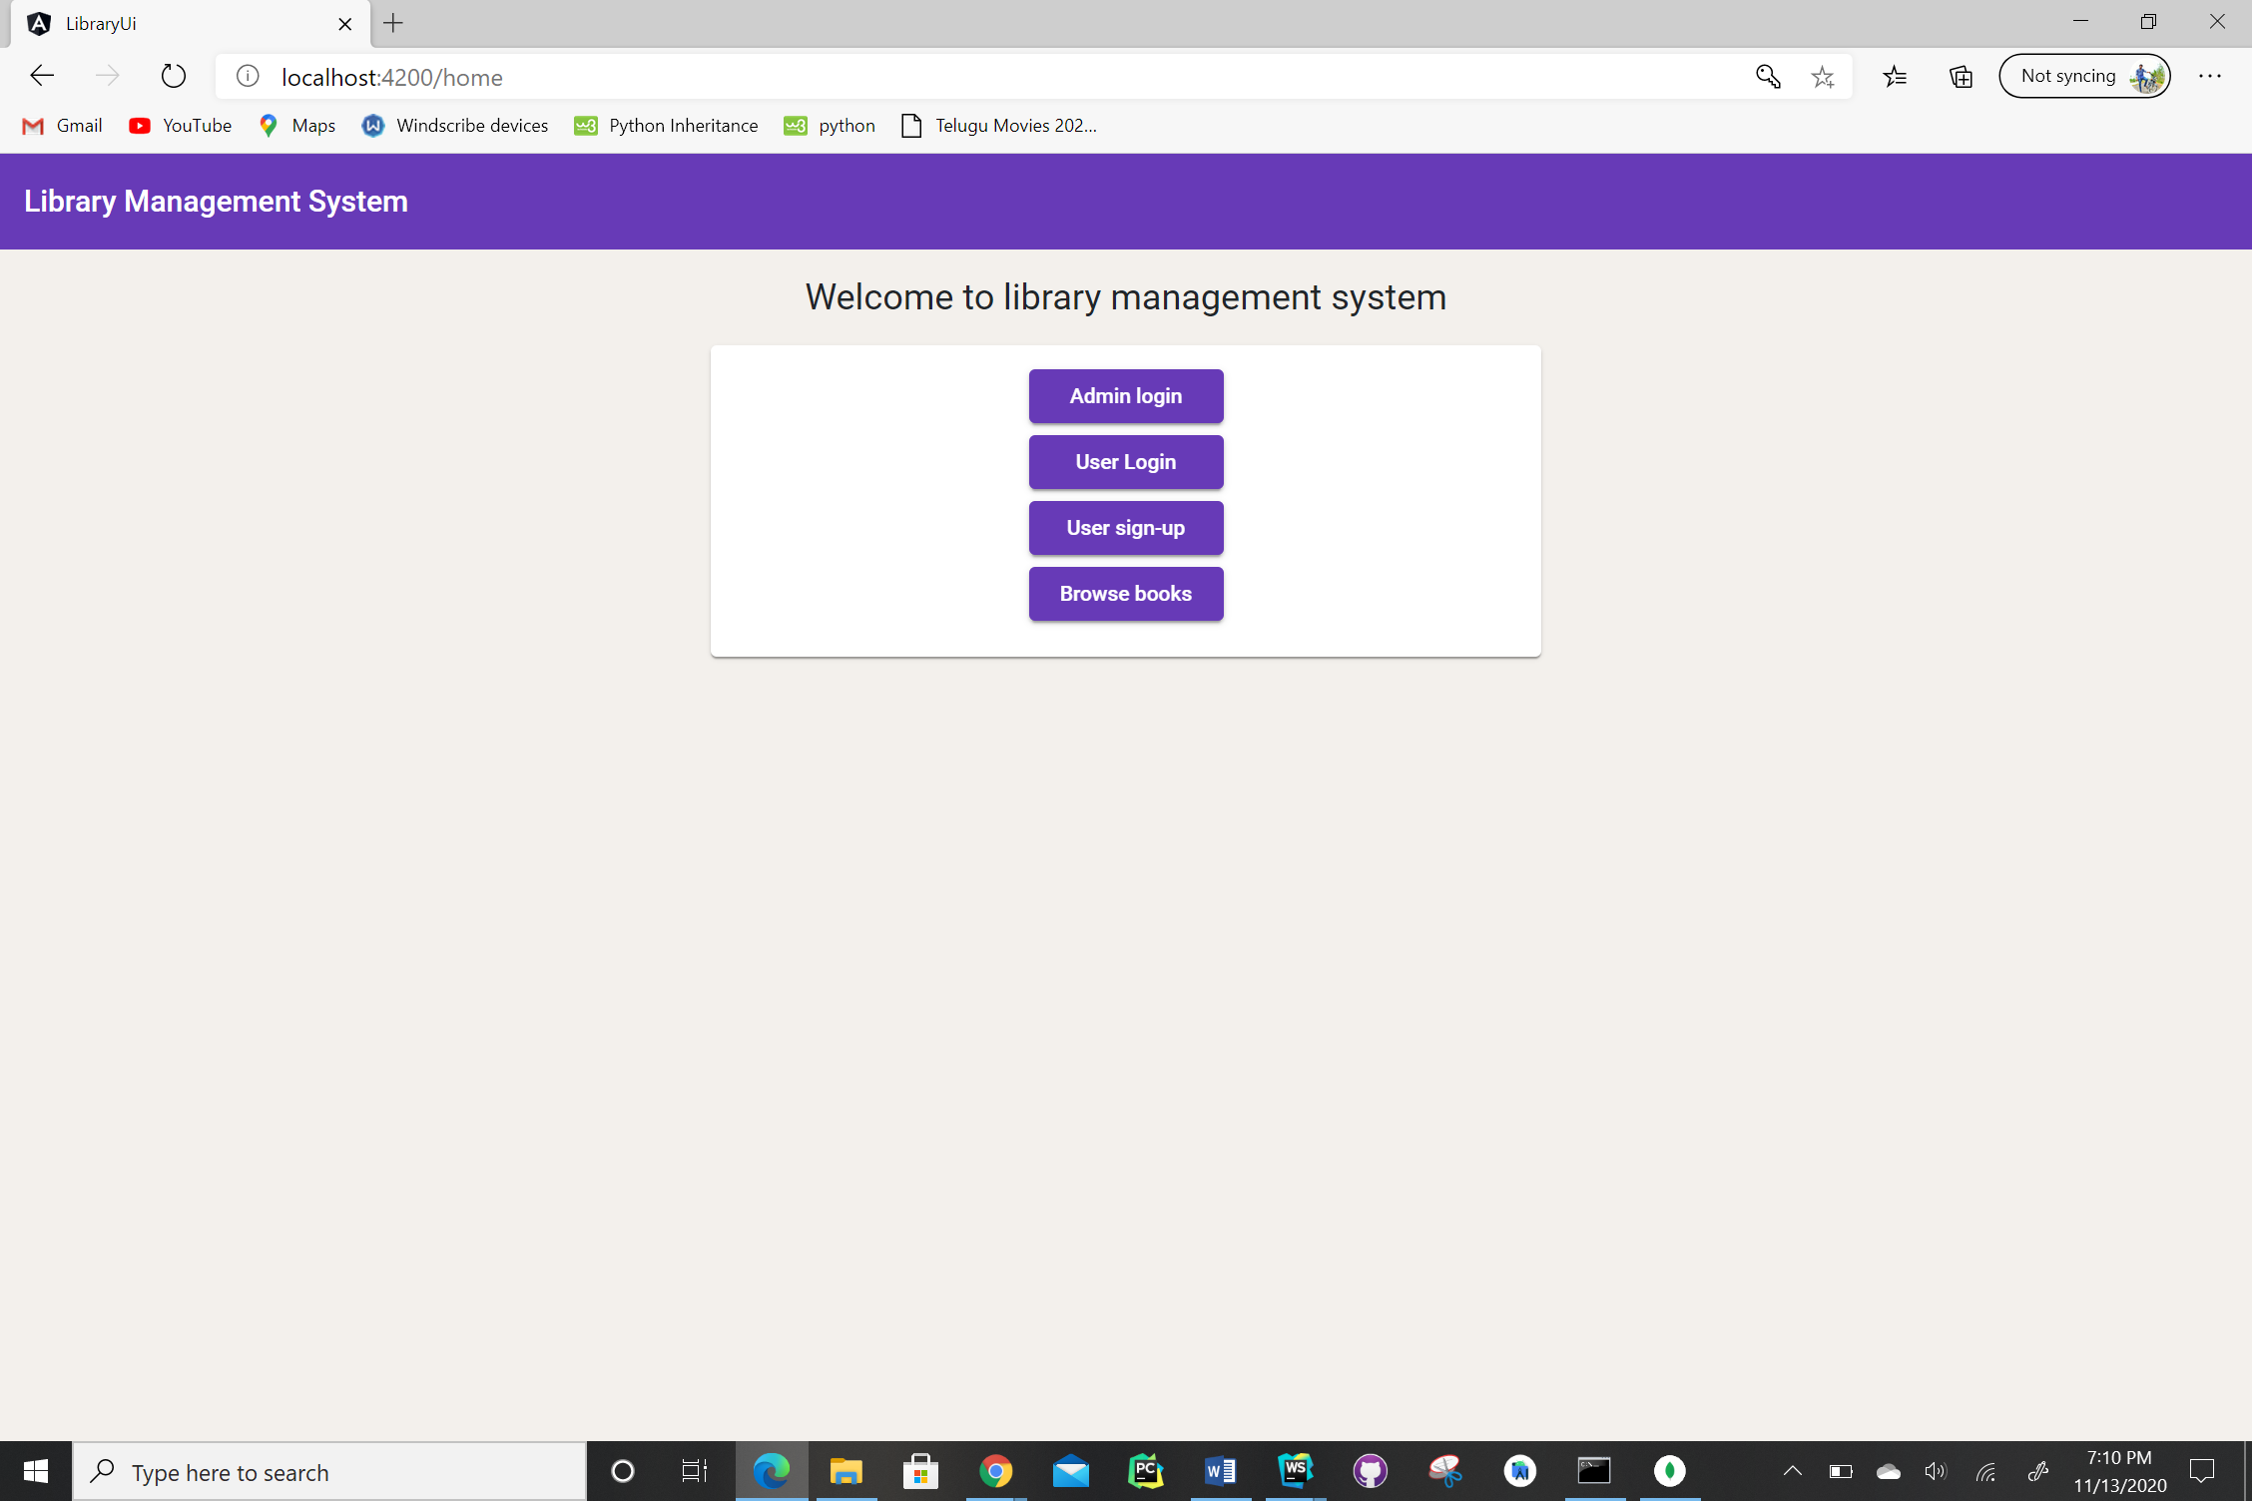

1. Please find the admin login page below.

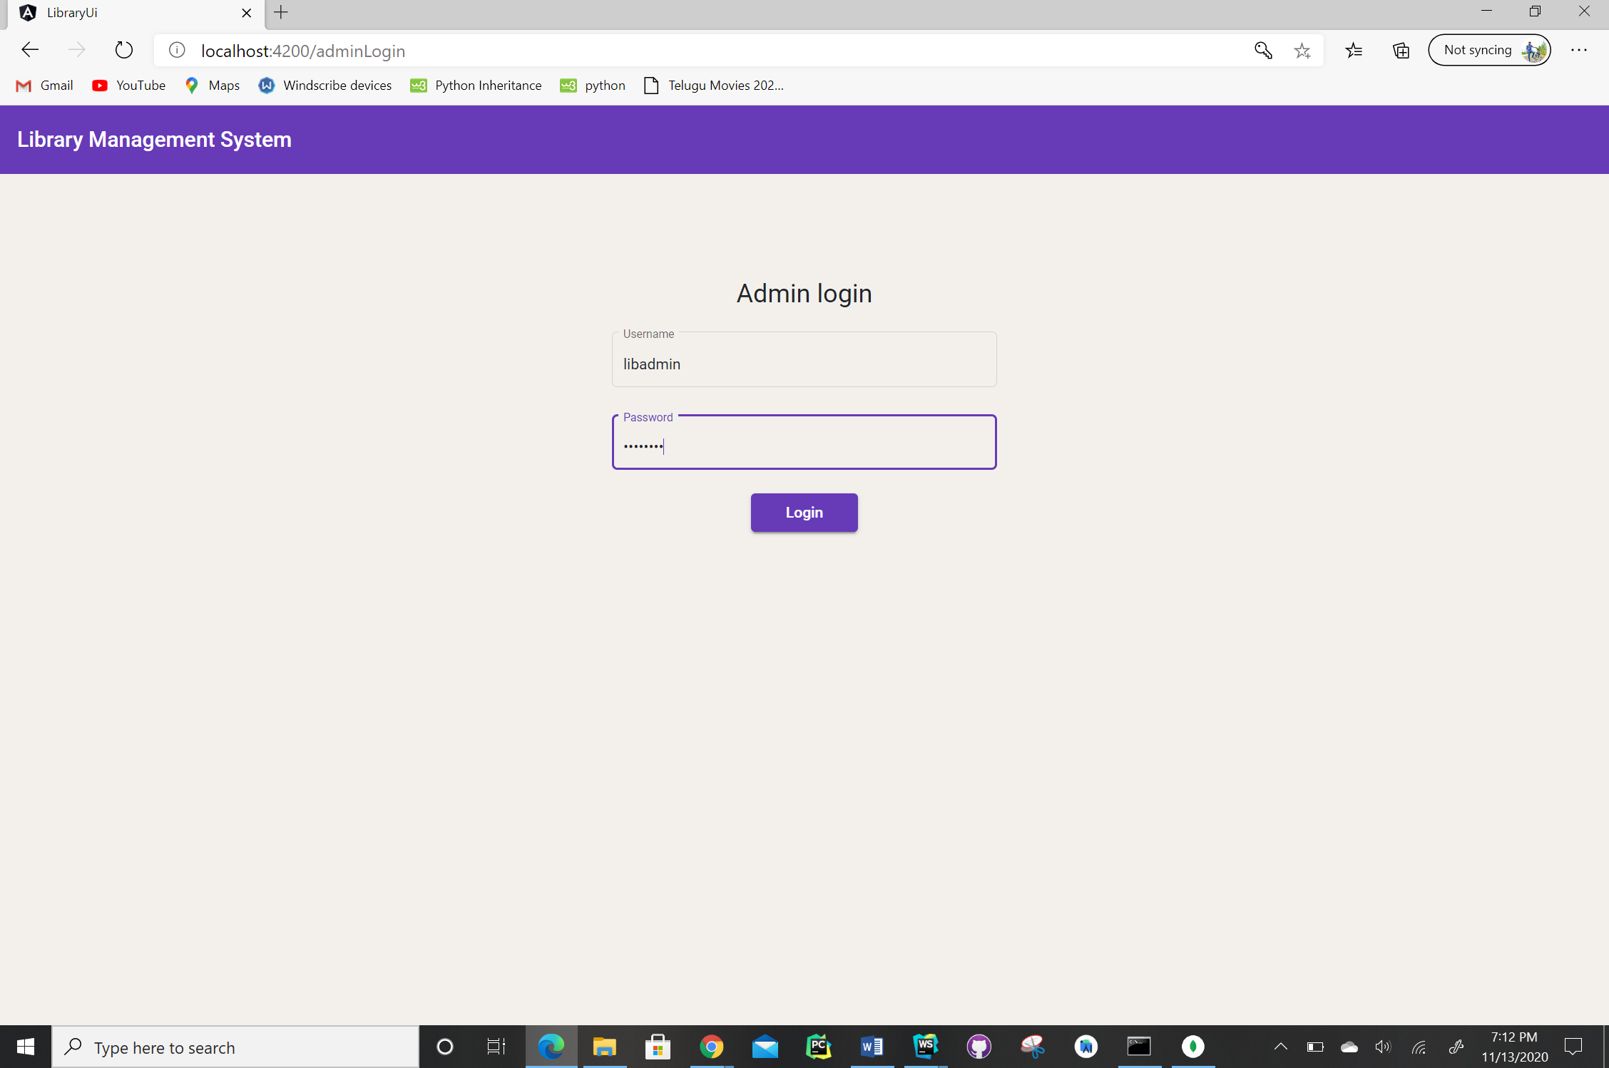

1. Please find the admin dashboard screen below. This screen consist of the privileges for admin in the form of buttons and also the list of books in the inventory with 5 books displayed at a time. The details of the books can be edited from this screen.

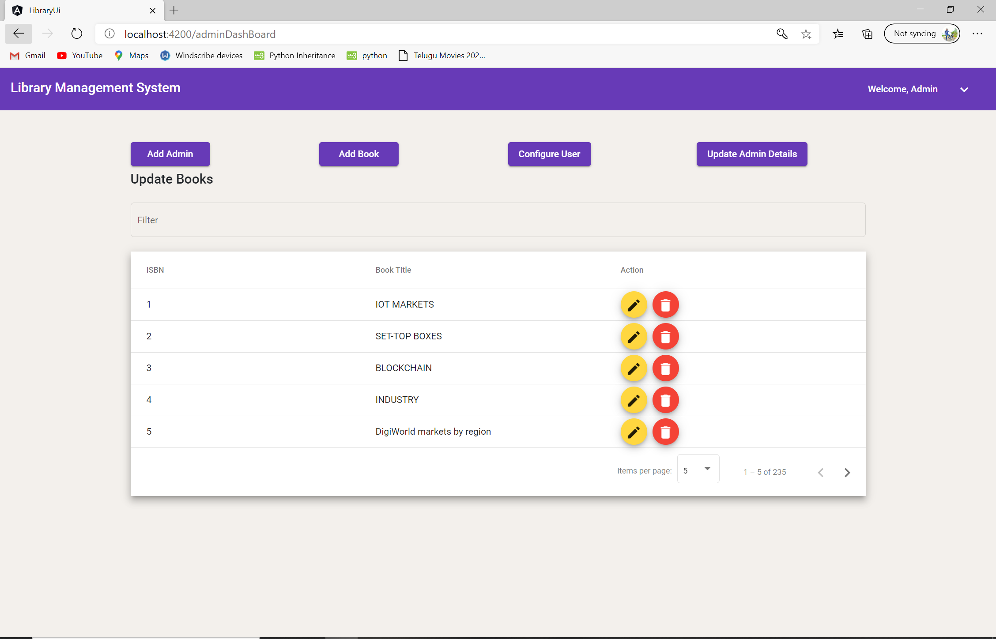

1. Please find the “Add Admin” screen below.

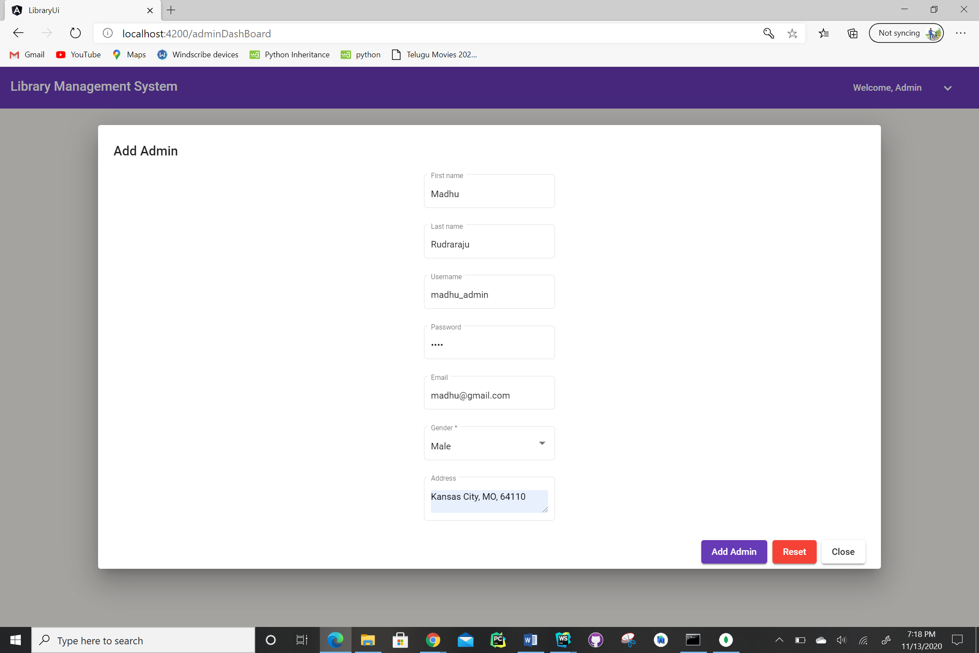

1. Please find “Add Book” screen below.

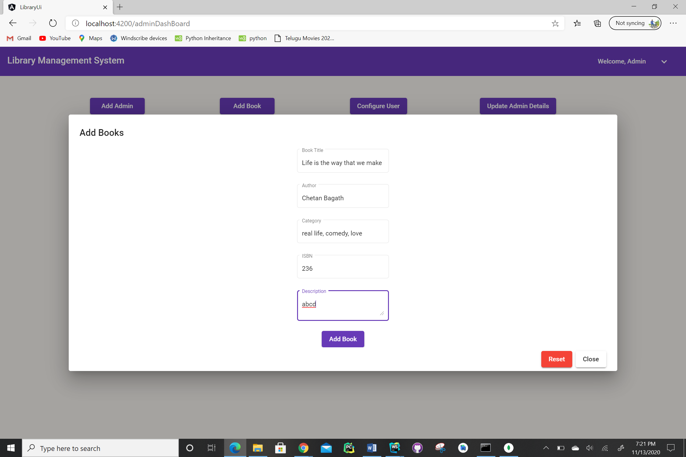

1. Please find “Configure User” screen below. In this we will be able to delete the registered users in our application.

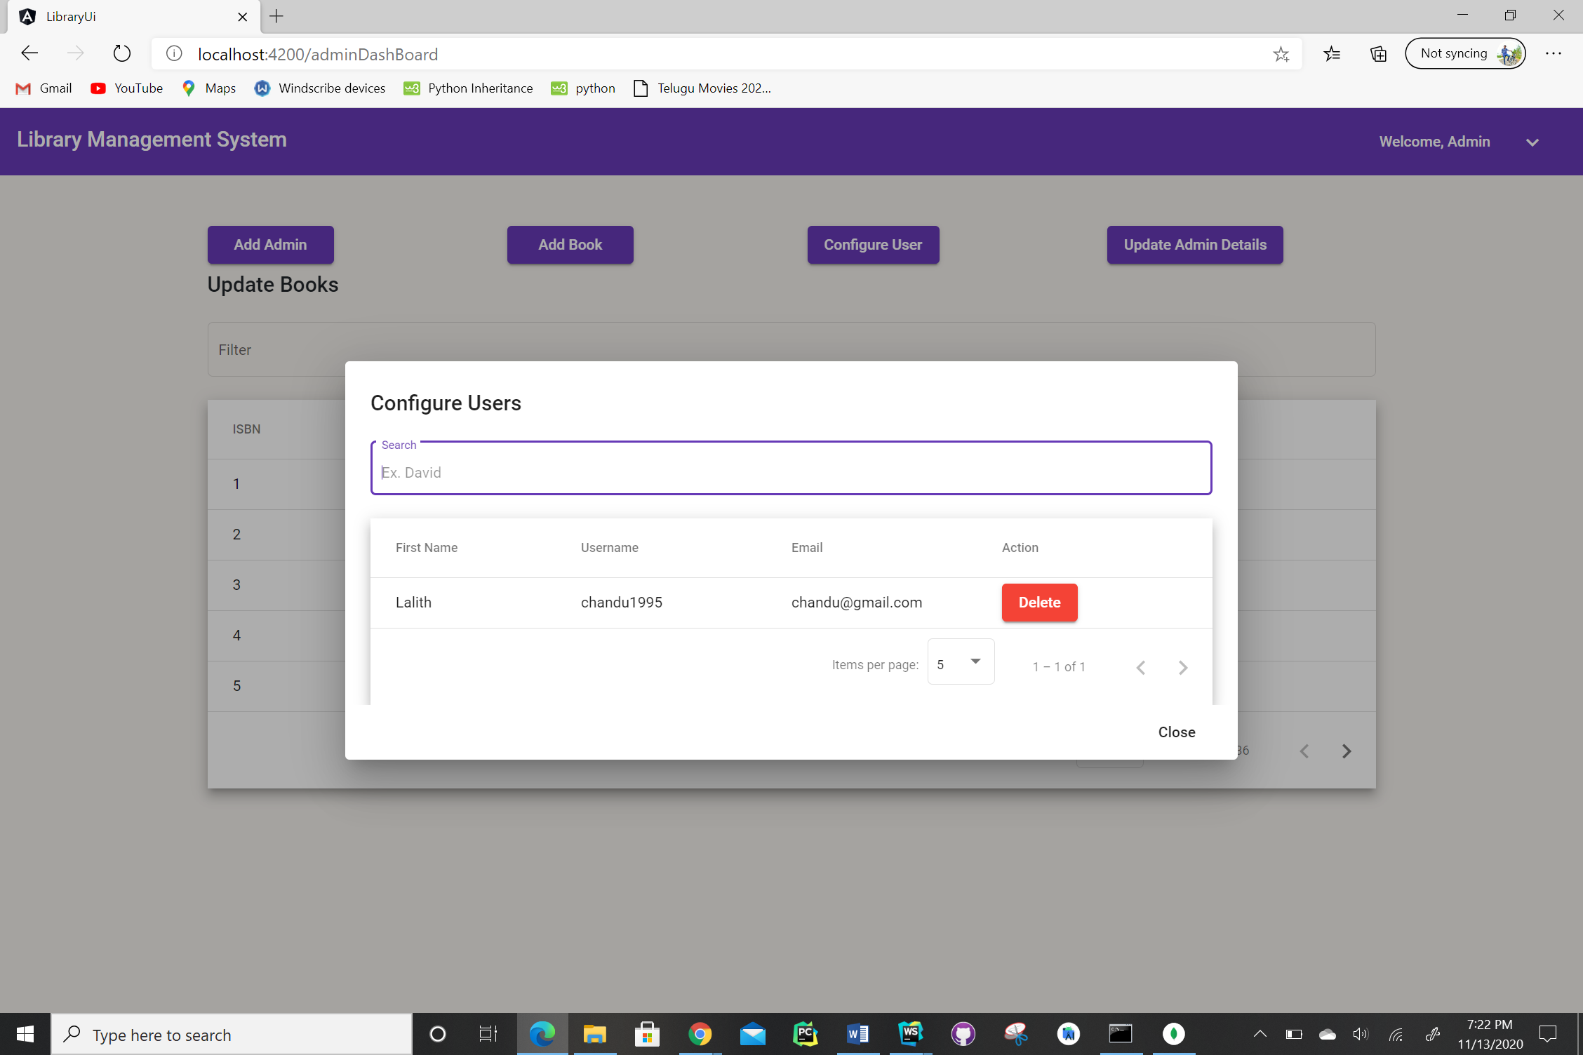

1. Please find “Update Admin Details” screen below. In this one admin will be the default admin which cannot be edited. Remaining admin details can be edited.

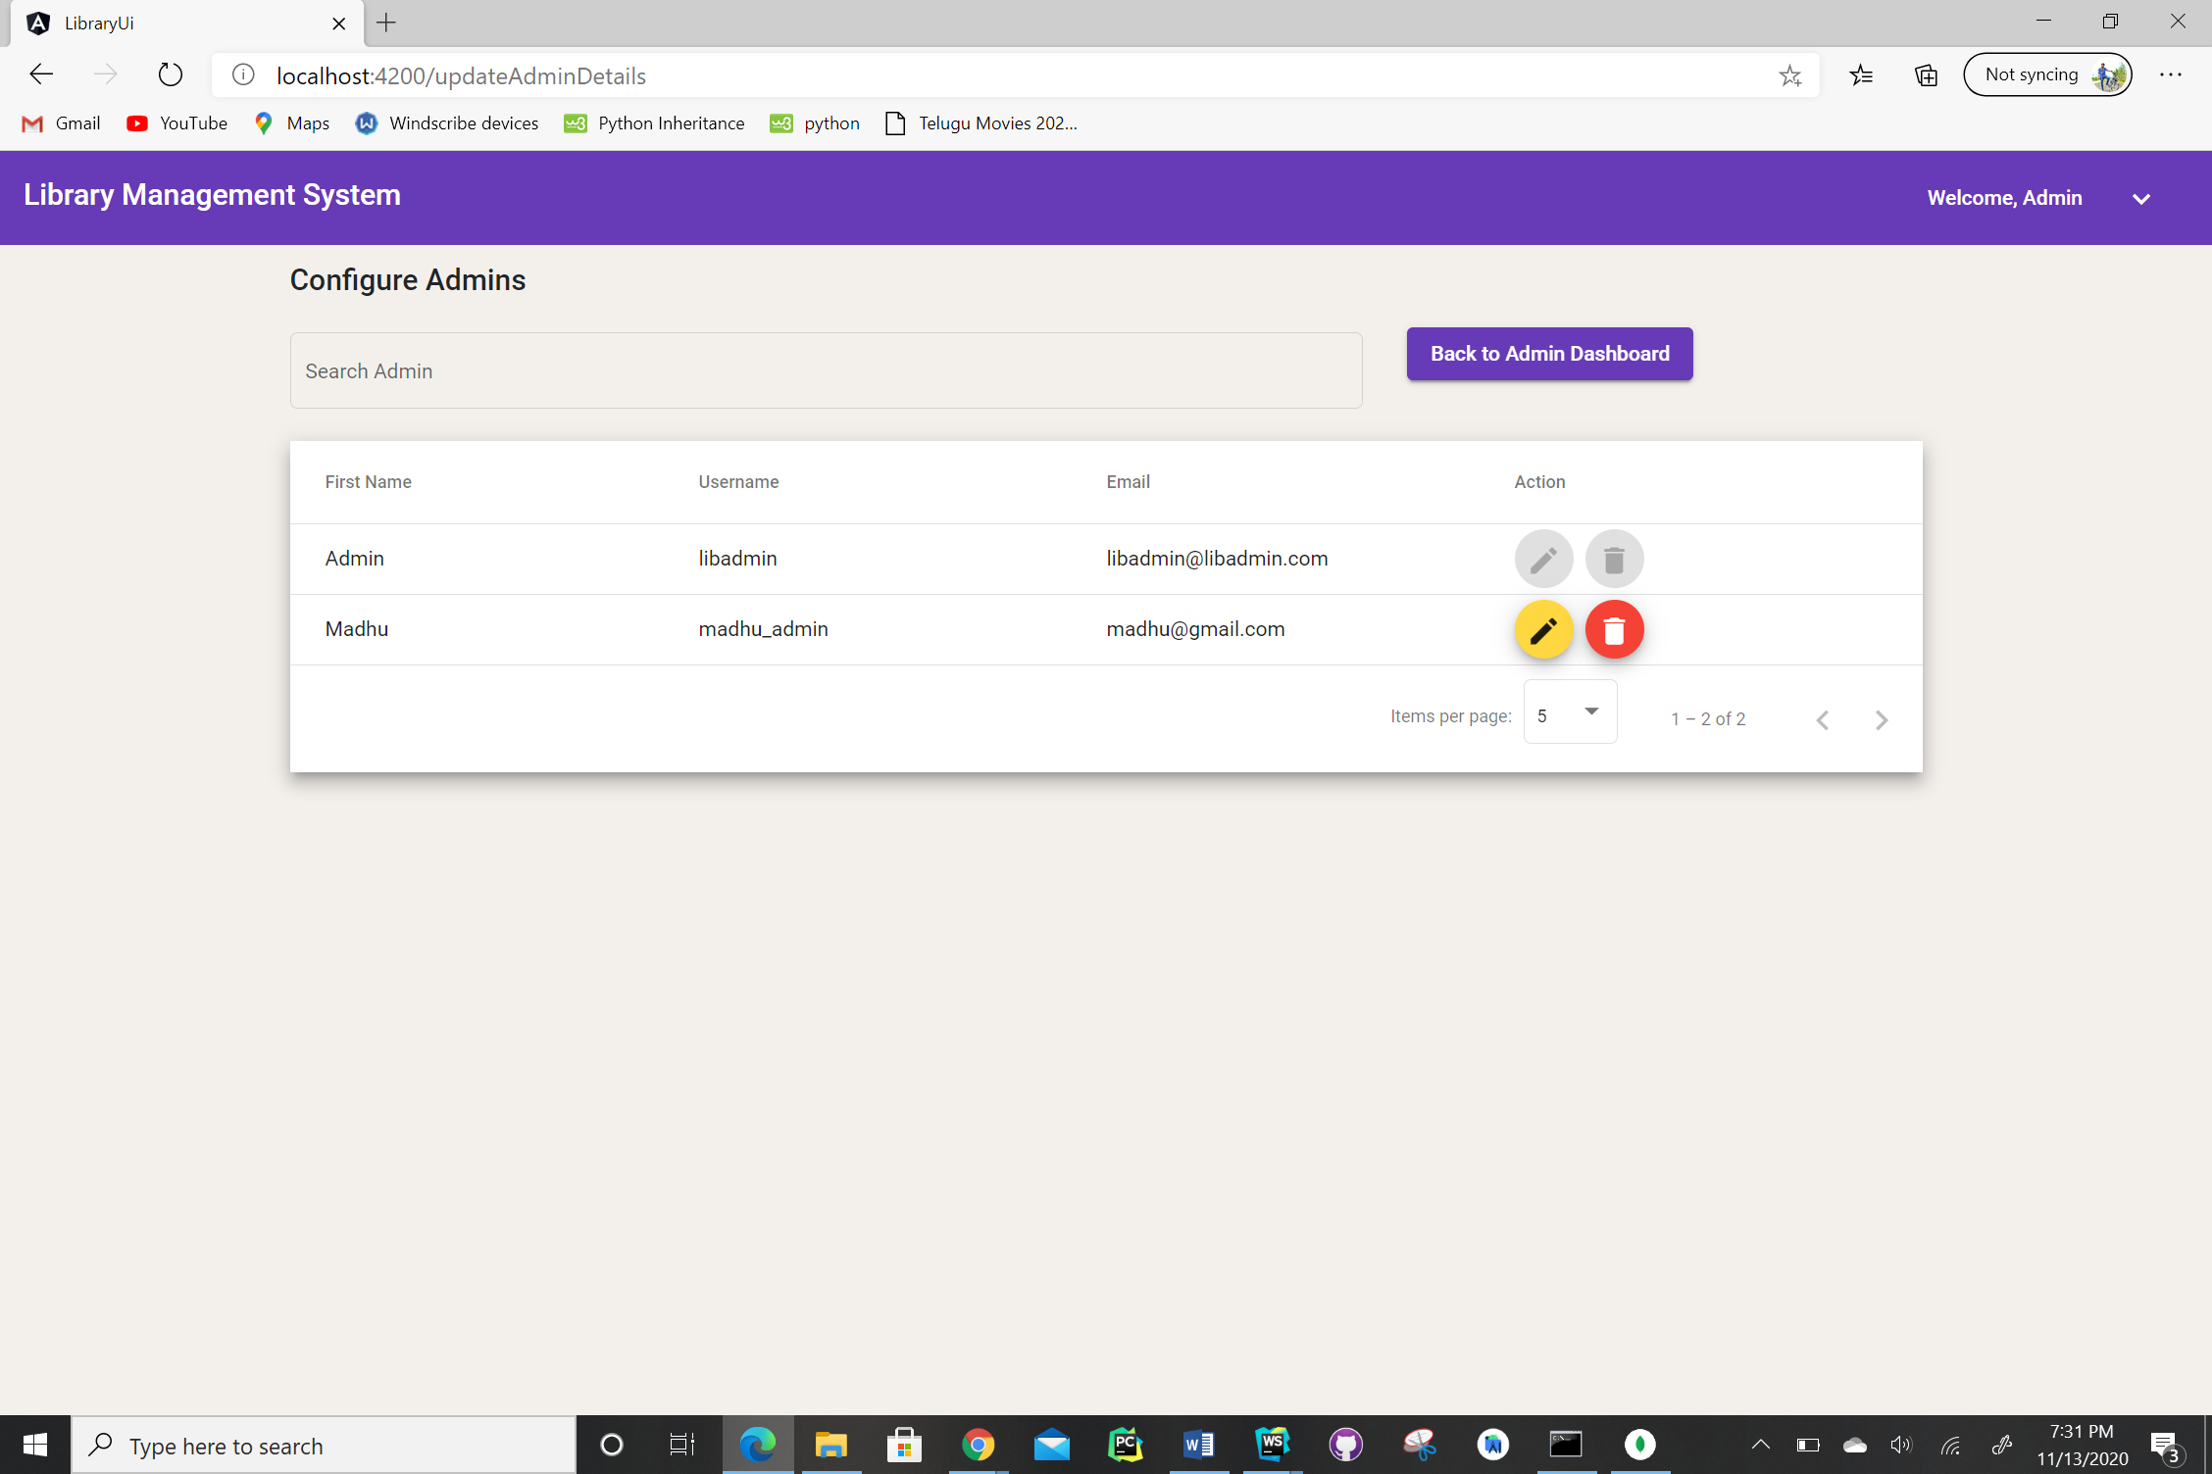

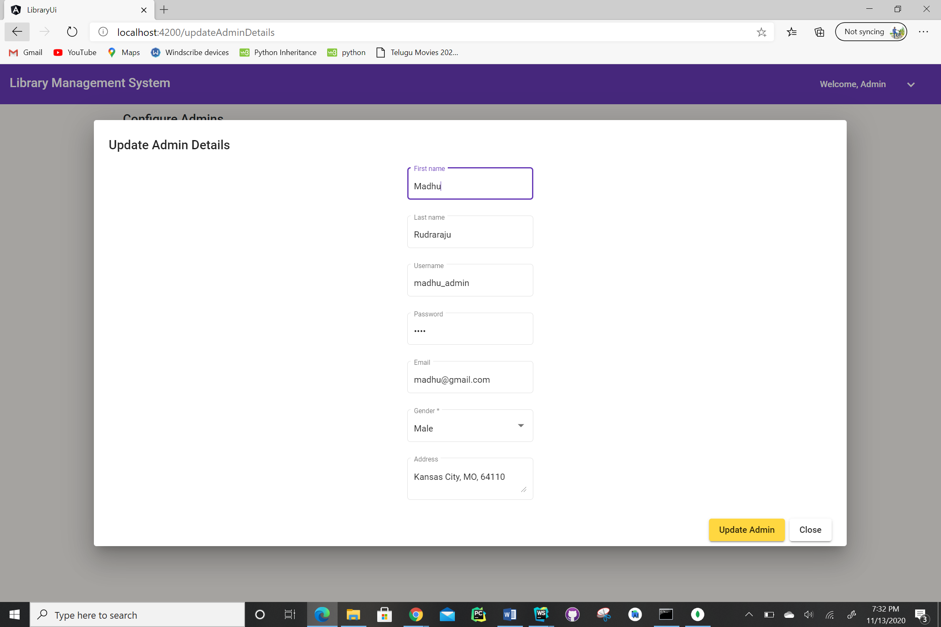

1. When admin is already logged in and goes to home screen please find the screen below.

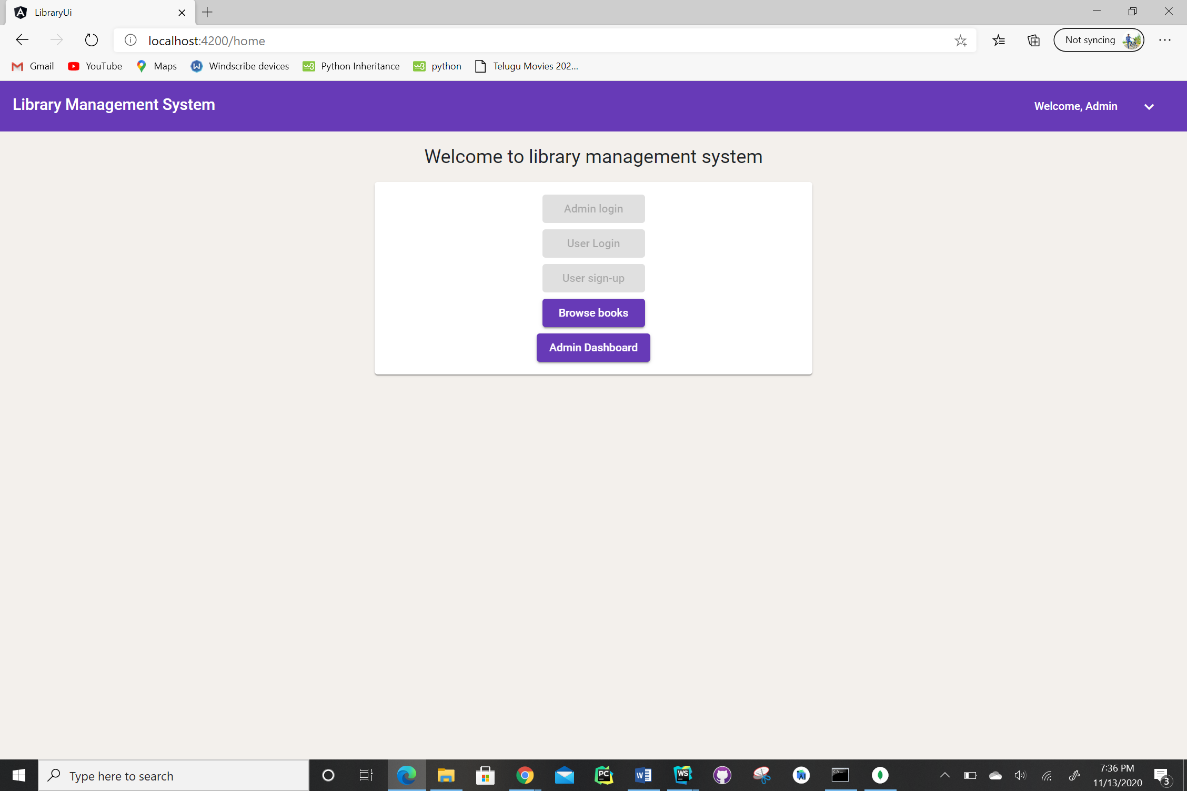

1. Please find the user login screen below.

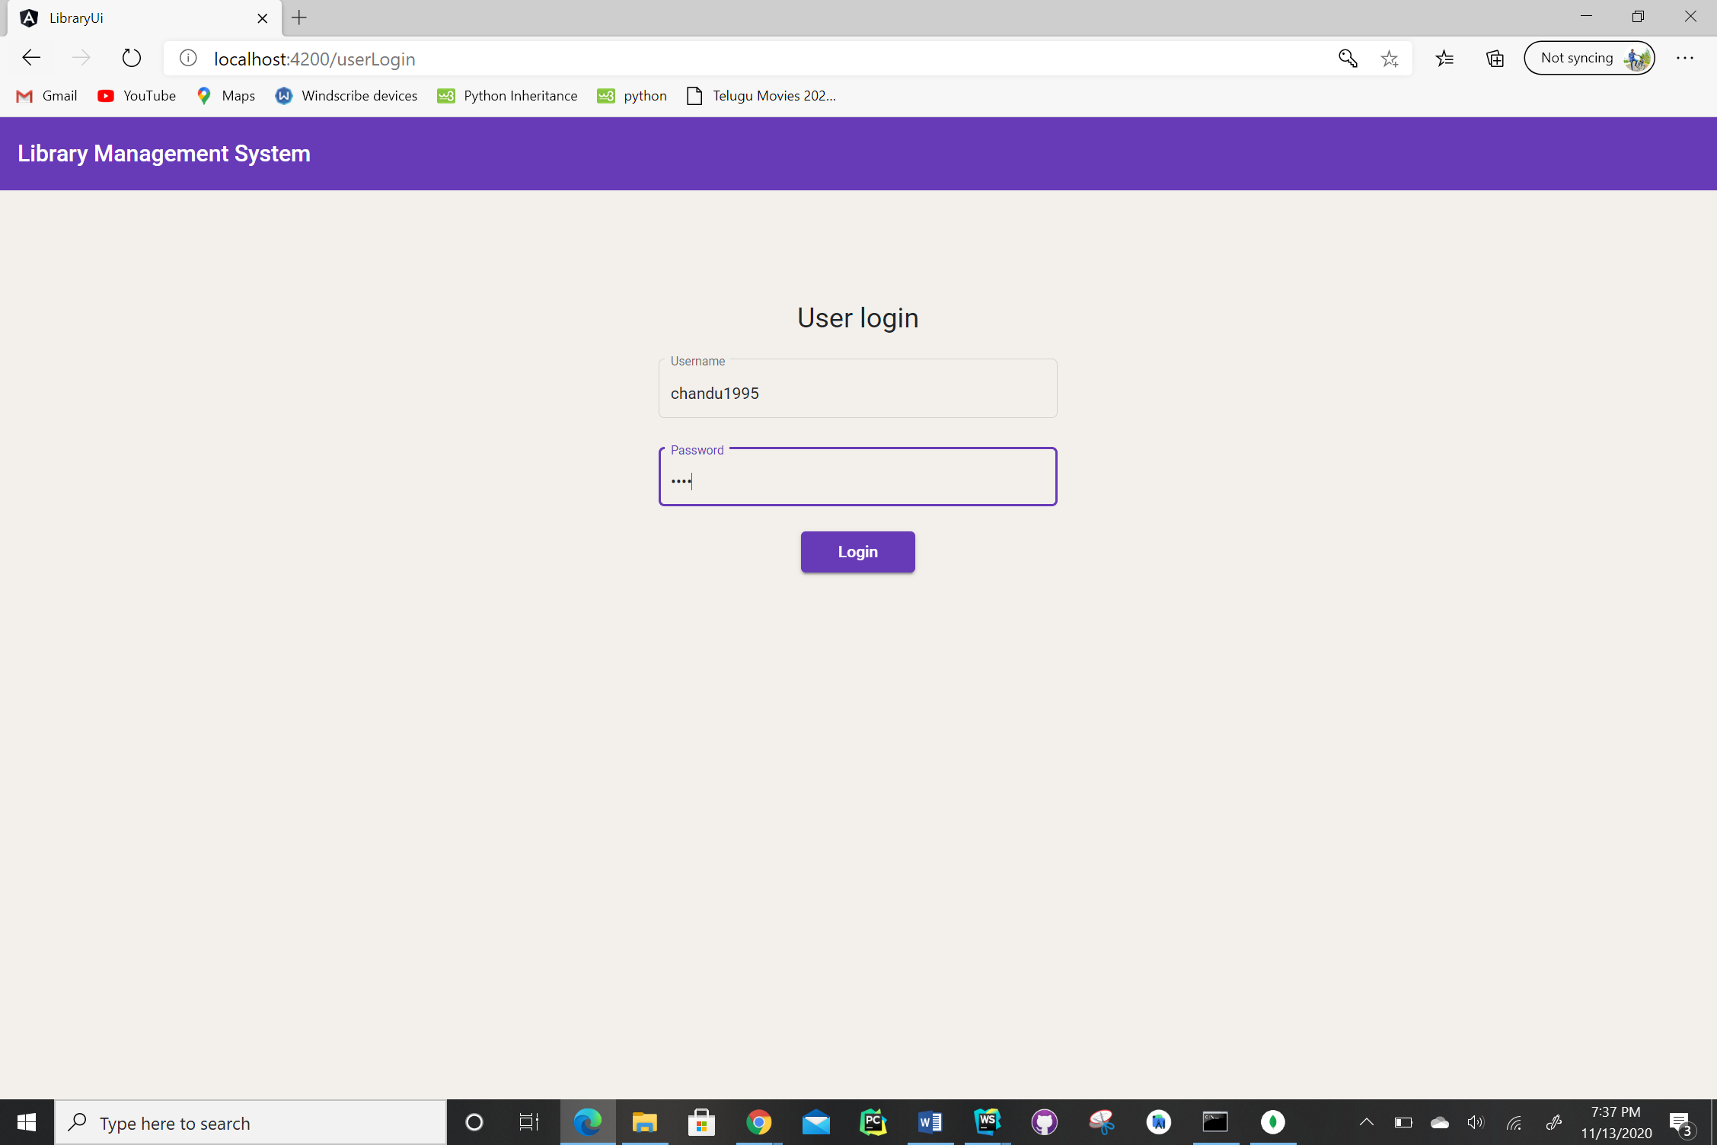

1. Please find the user dashboard screen below. This screen contains user privileges and user activity log.

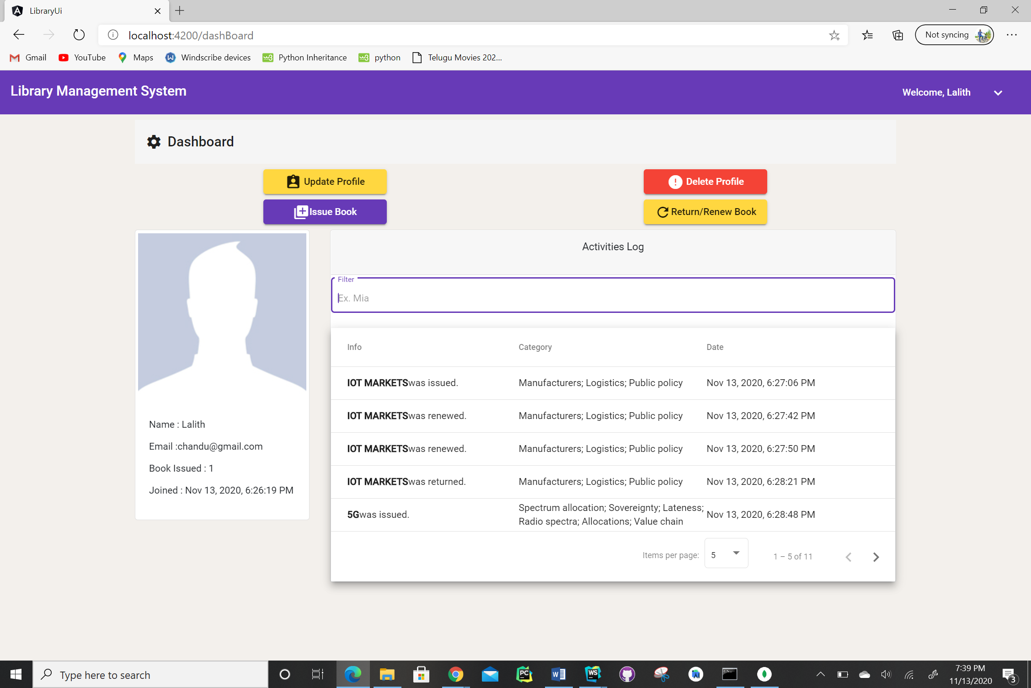

1. Please find user profile update screen below.

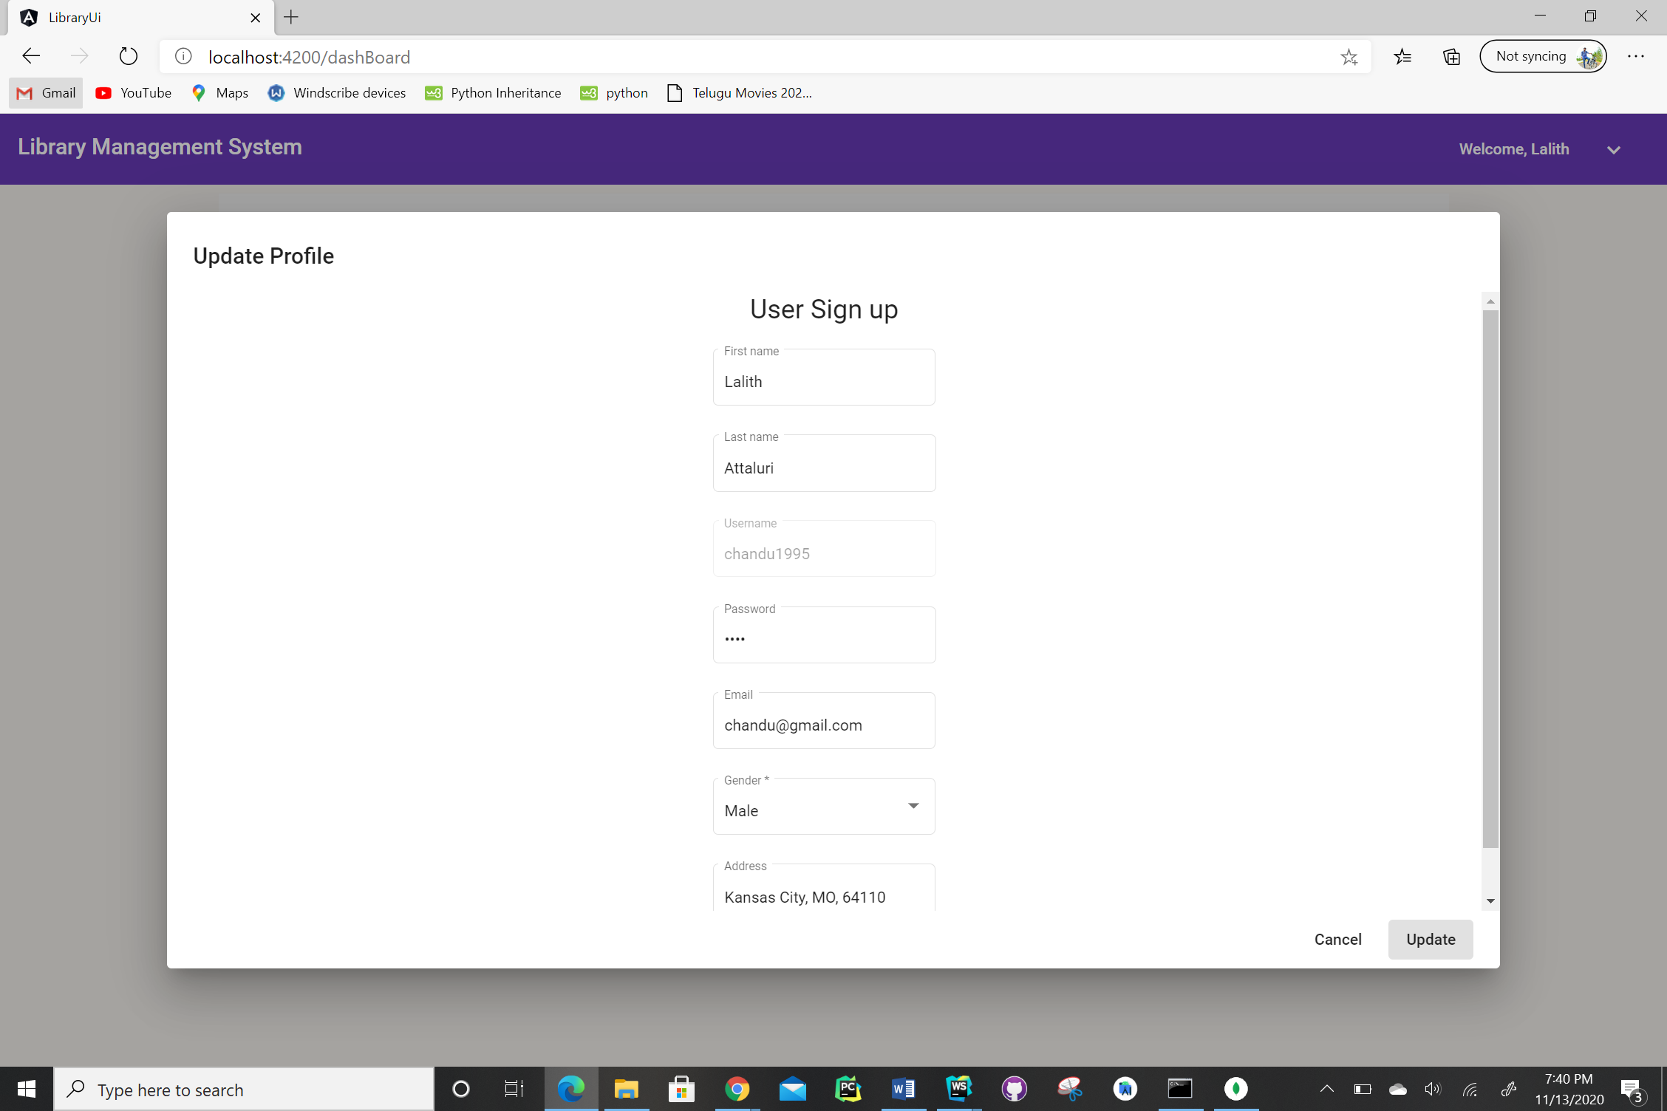

1. Please find issue book screen below.

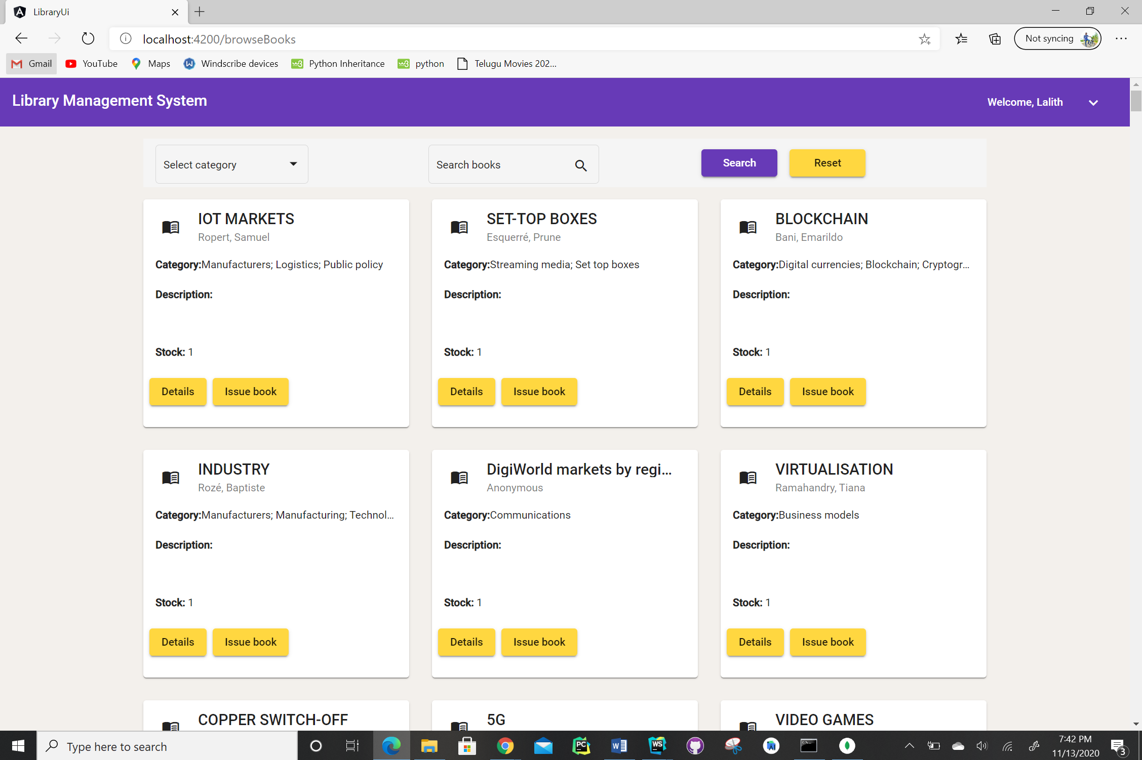

If we click on issue book then book will be issued and stock will be updated to 0 and it is no longer available for checkout.

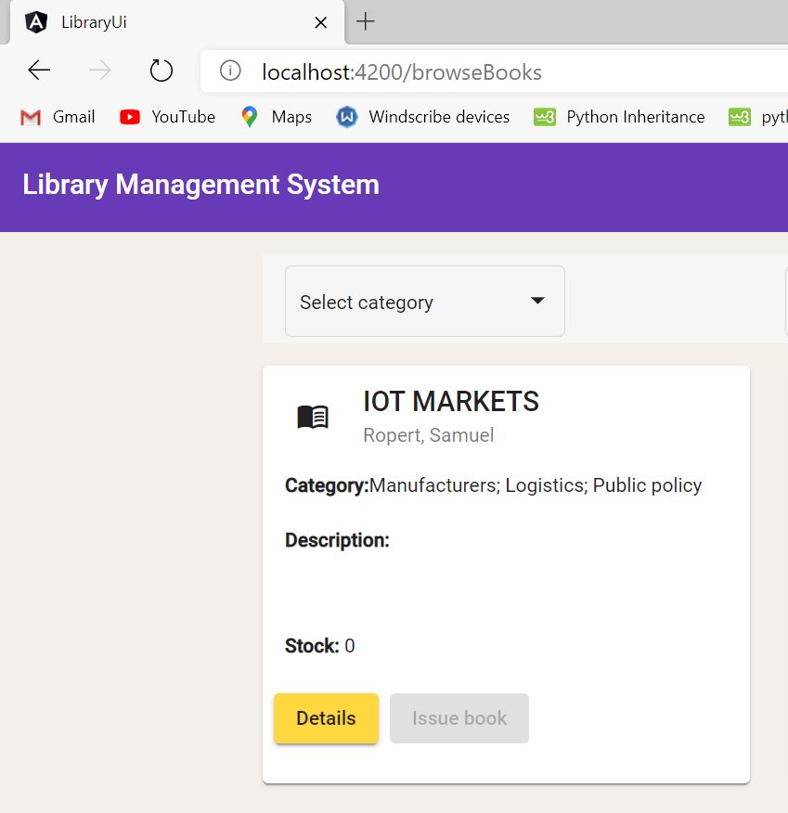

1. Please find user renew and return screen below.

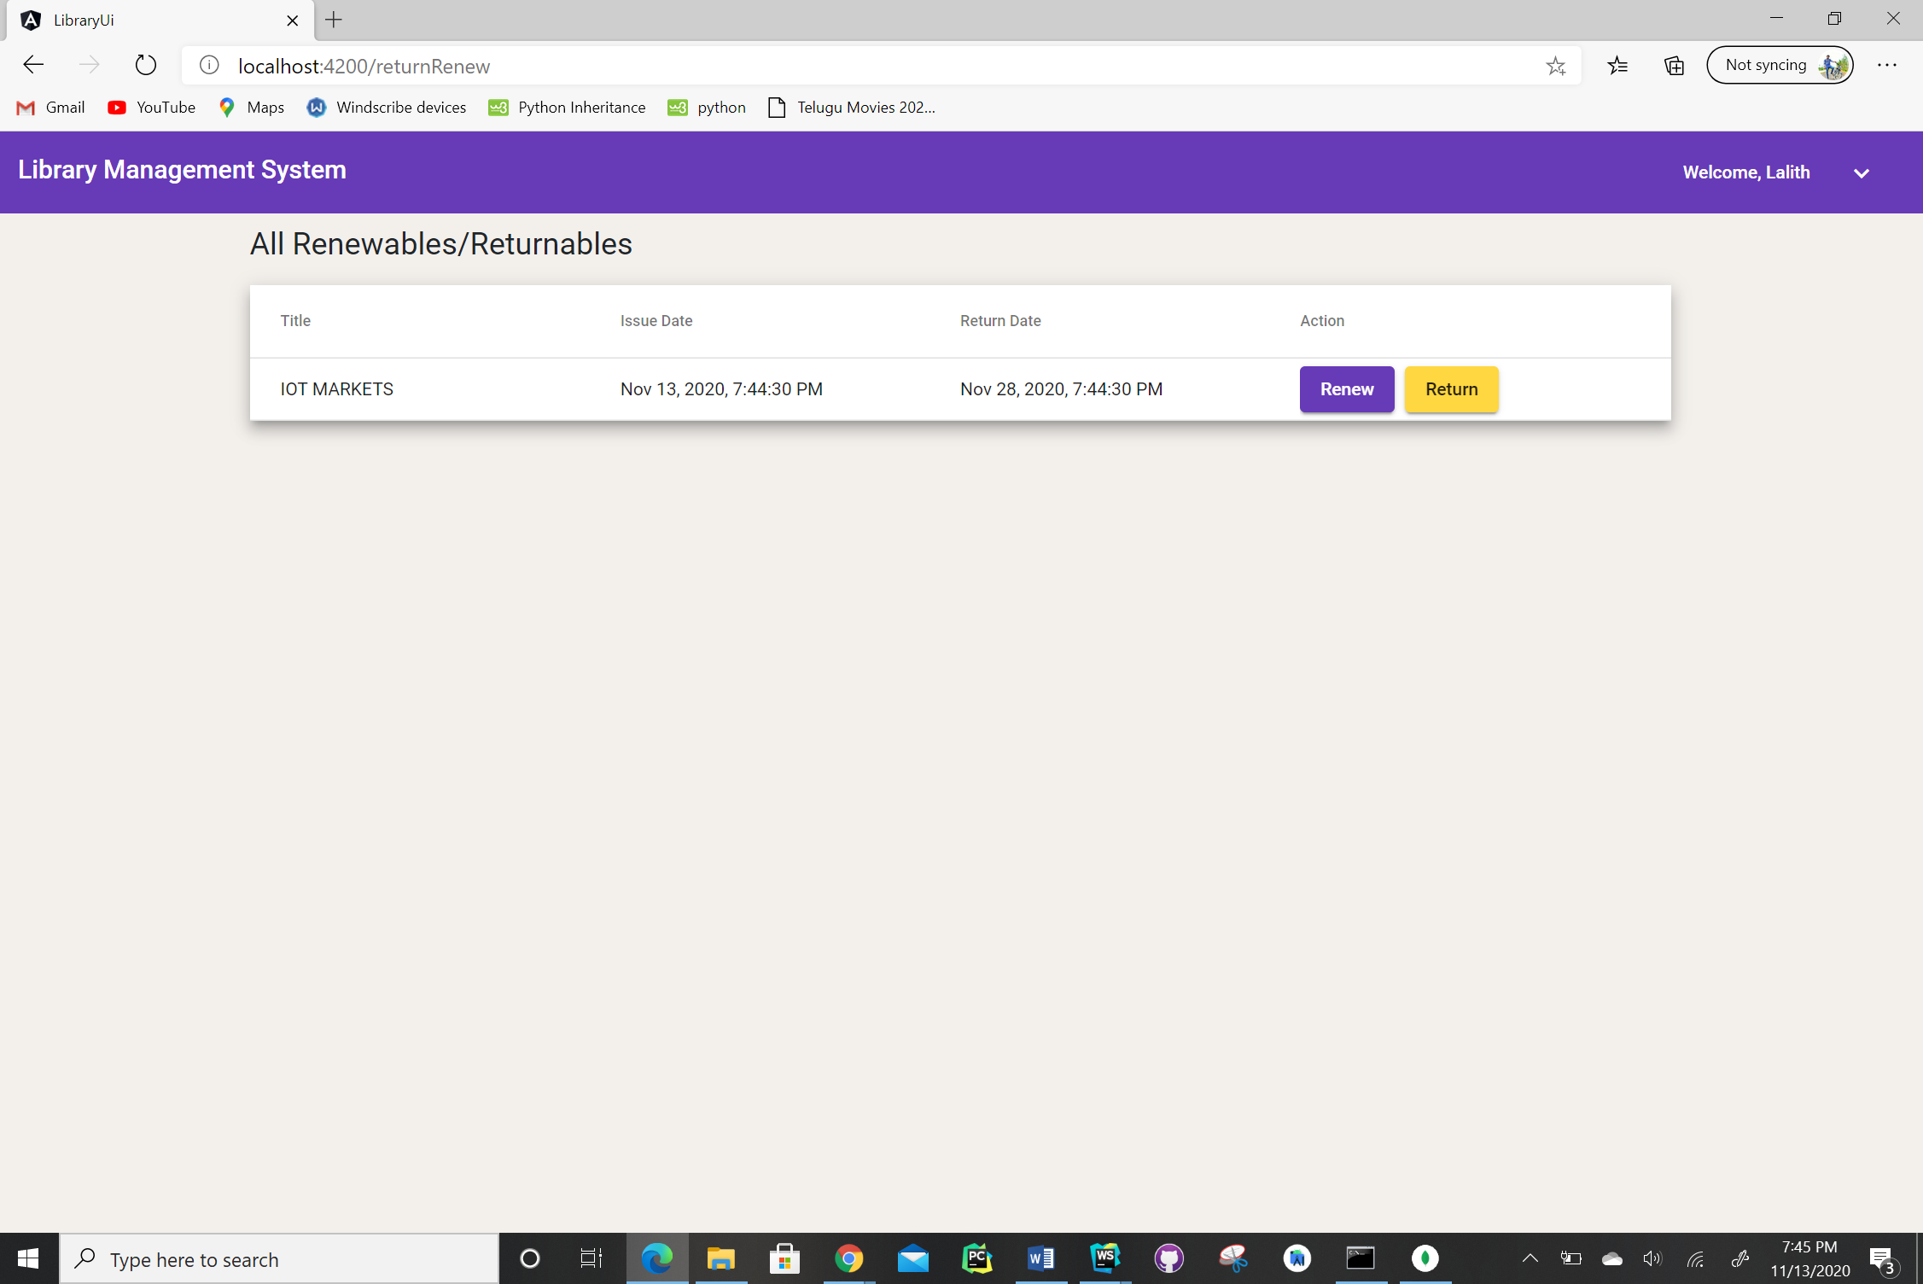

1. Please find user signup screen below.

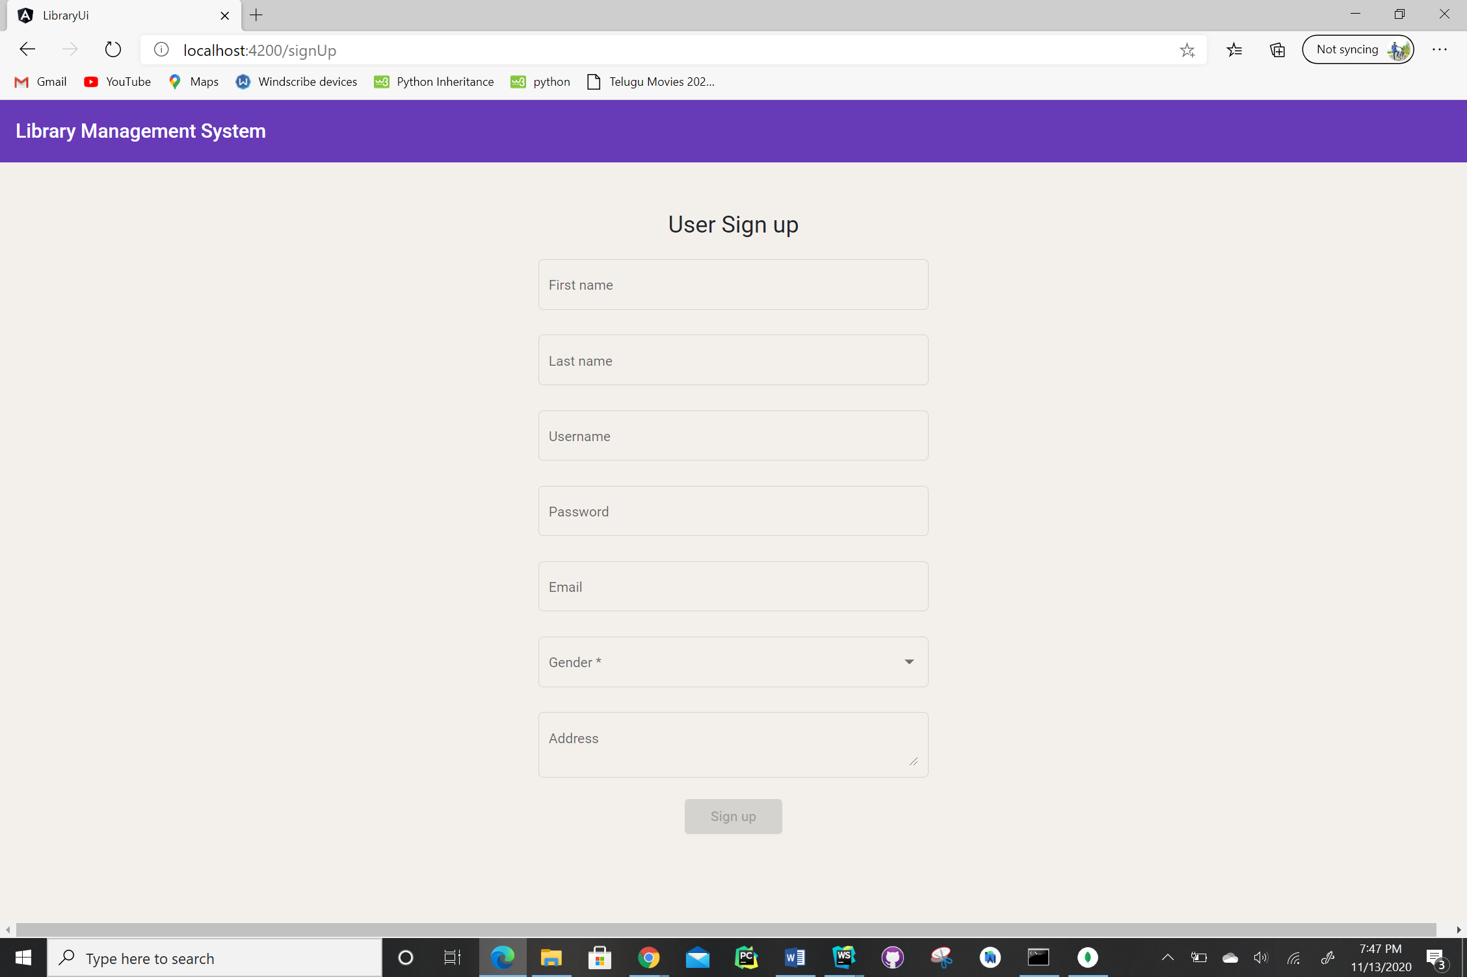

1. Please find browse books screen below. Books can be searched by title, author, category and ISBN.

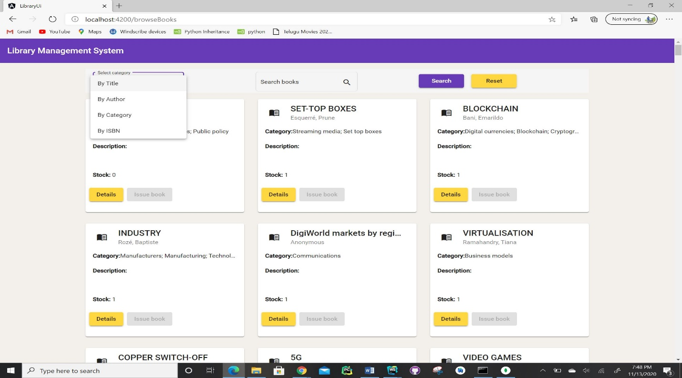

Title search:

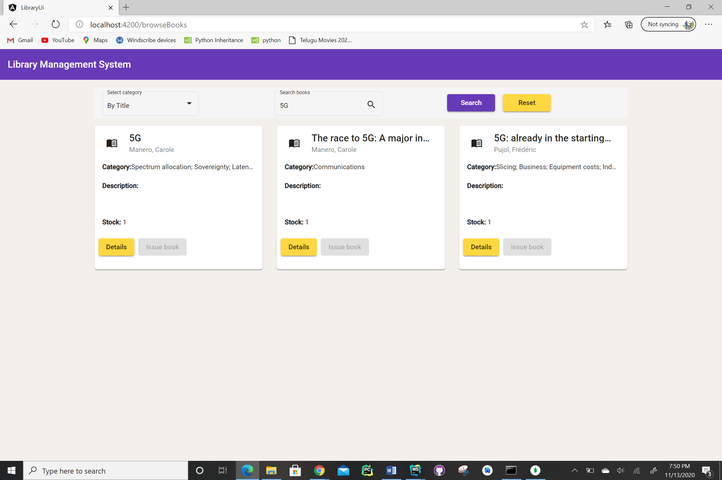

Author search:

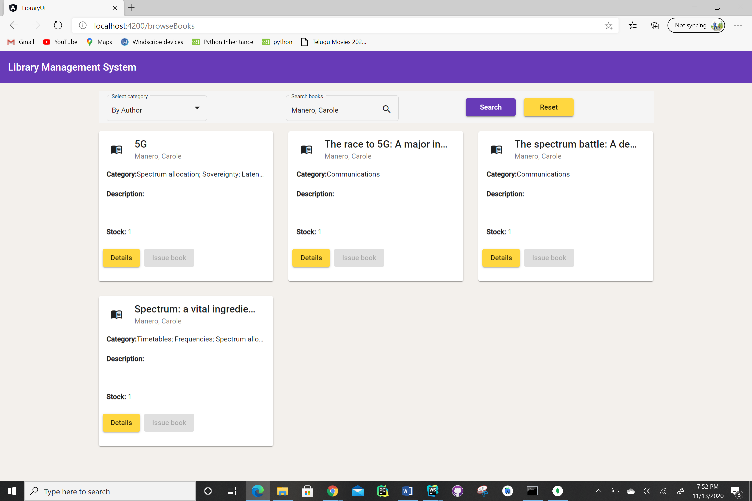

**Improvements from the previous Increment:**

As mentioned in the earlier report we were working on Browse books by category. In the dataset which we have built each book belongs to multiple categories which are present in the same column but separated by ‘;’. Earlier code used to interpret all the categories as a single string hence we need to enter the exact string present in the dataset entry to search the book which means we must enter all the categories to search a book which is not suitable for Real time applications. Hence, we have added pattern matching in which even though we enter single category of the book it performs pattern matching and returns all the books that contains the given category.

Please find the below screenshot for browse books by category in which we are searching for the books that comes under “Manufacturers” category.

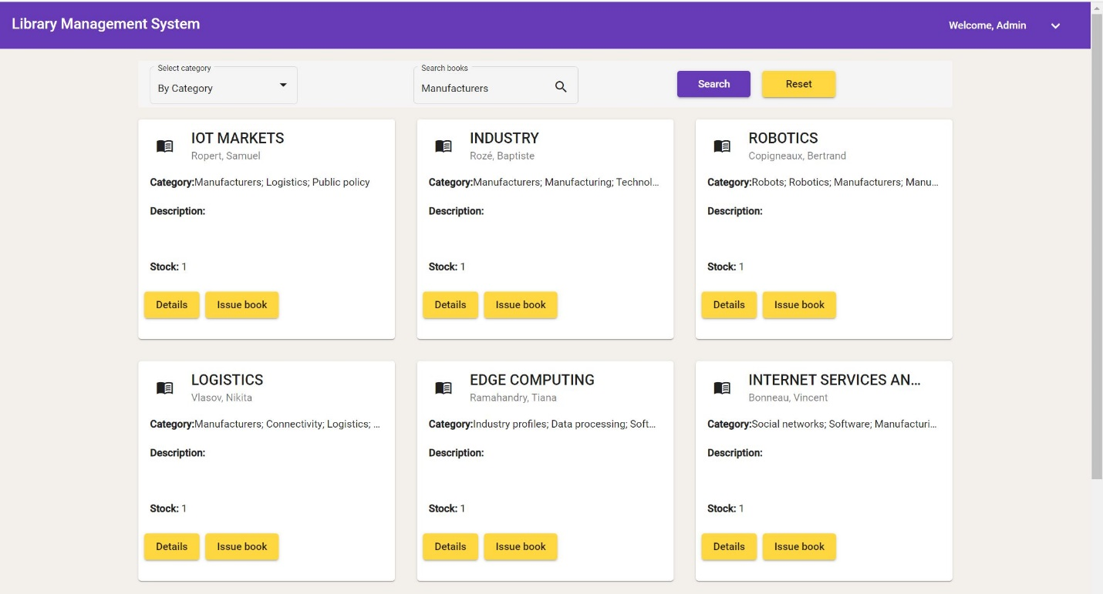

**Code Snippets:**

**Backend:**

* Please find the screenshot for index.js for backend:

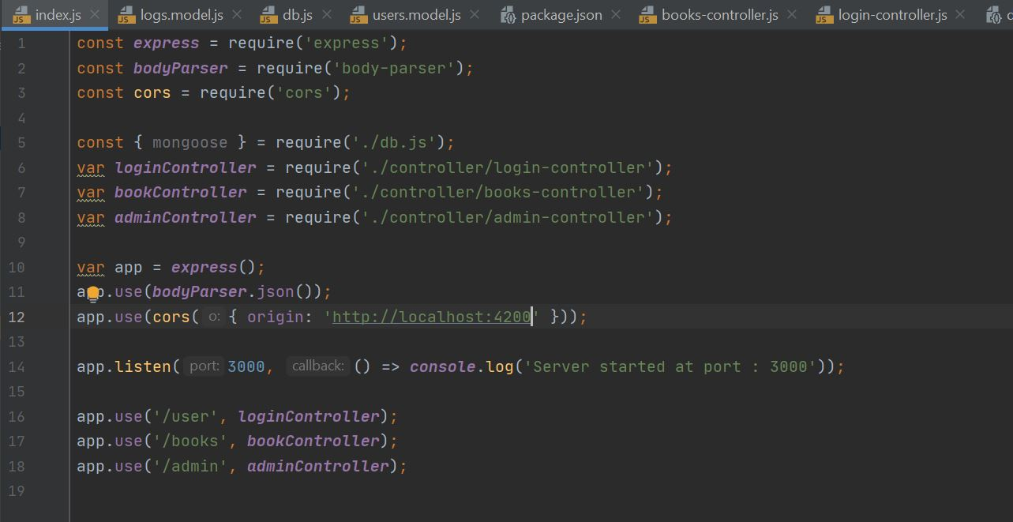

* Please find the screenshot for db.js for backend:

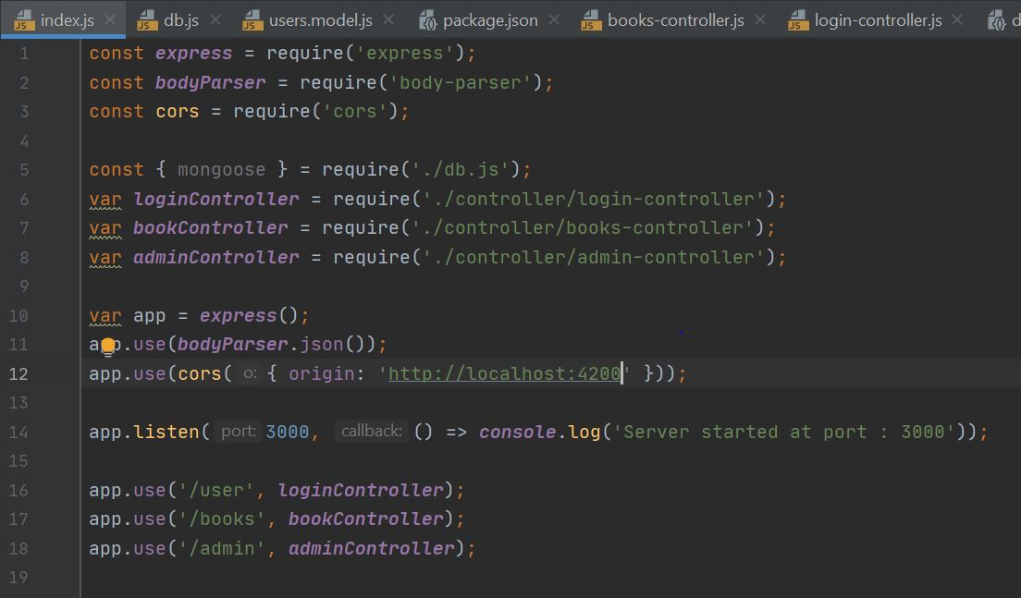

* Please find the screenshot for package.js for backend:

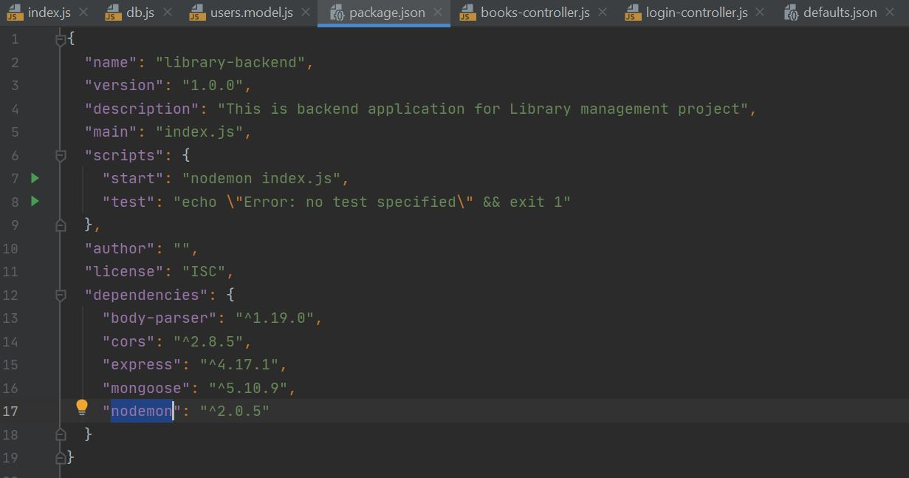

* Please find the screenshot for defaults.json for backend:

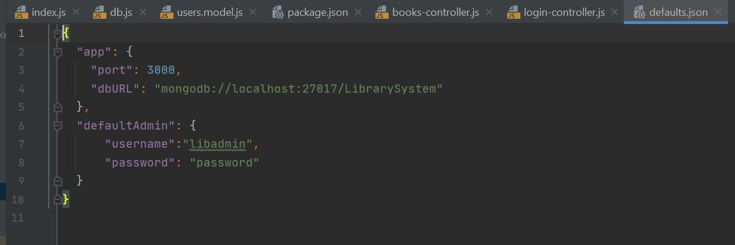

* Please find the screenshot for admin.model.js for backend:

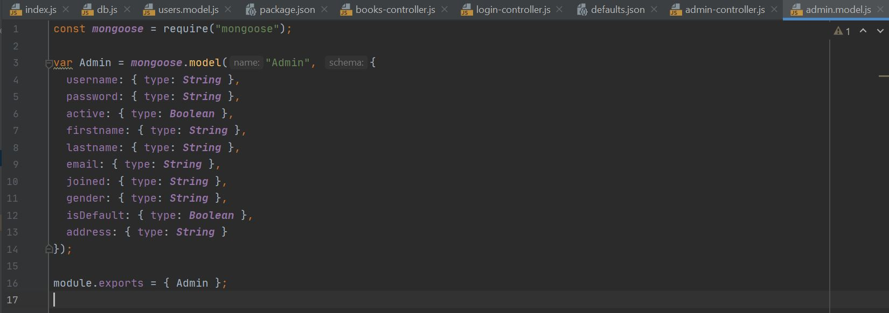

* Please find the screenshot for books.model.js for backend:

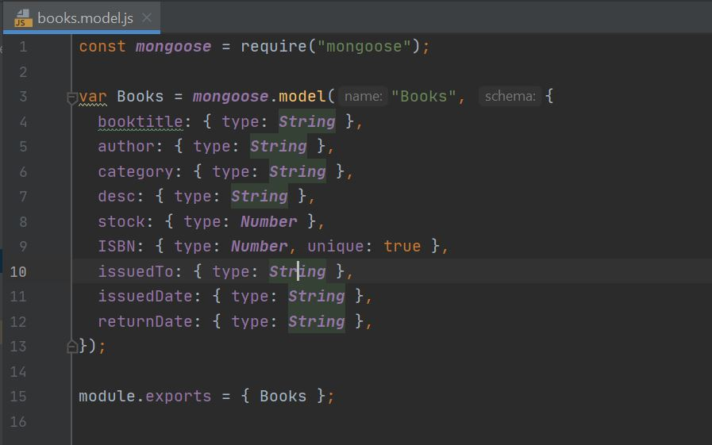

* Please find the screenshot for logs.model.js for backend:

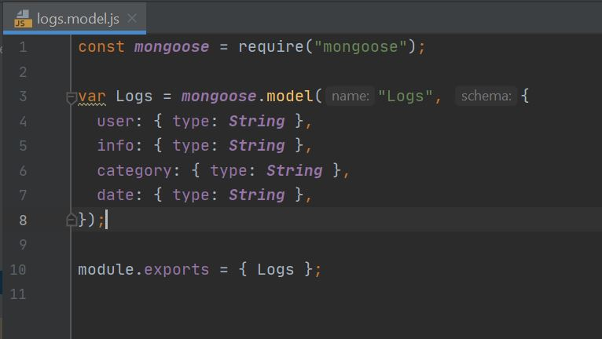

* Please find the screenshot for user.model.js for backend:

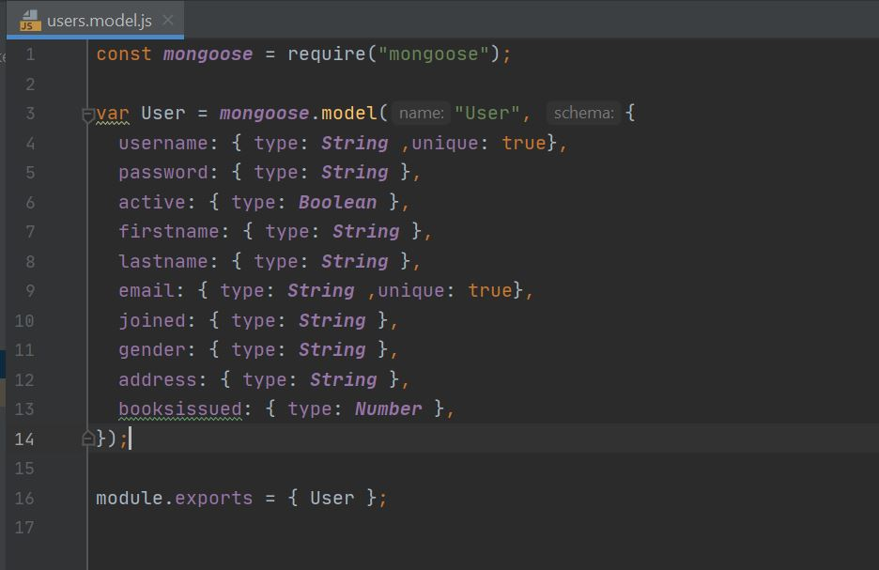

* Please find the screenshot for admin-controller.js for backend:

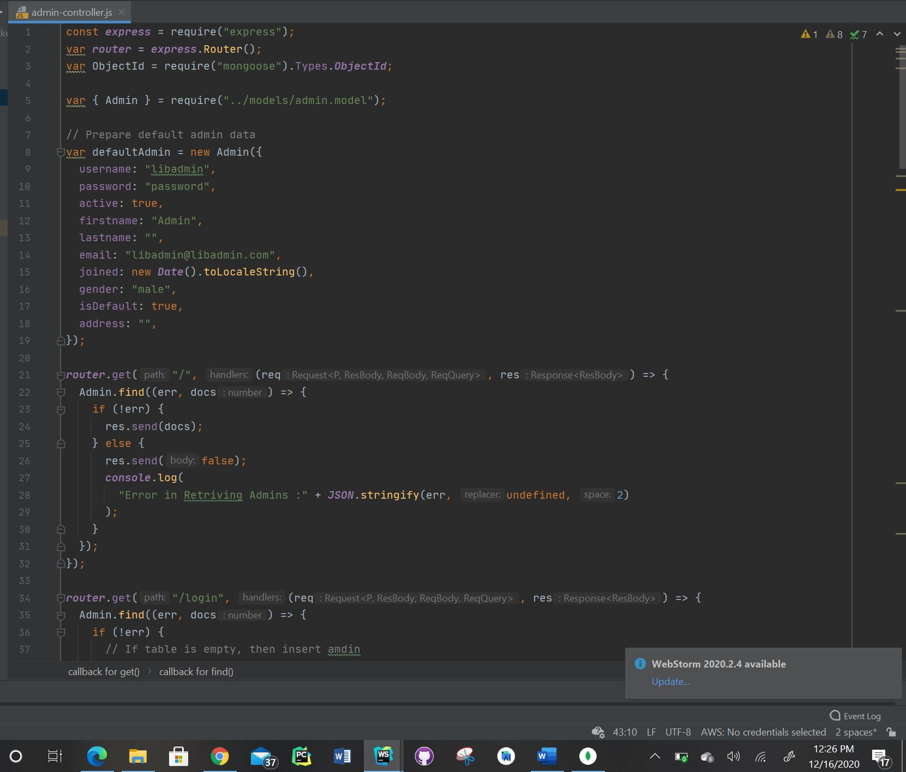

* Please find the screenshot for books-controller.js for backend:

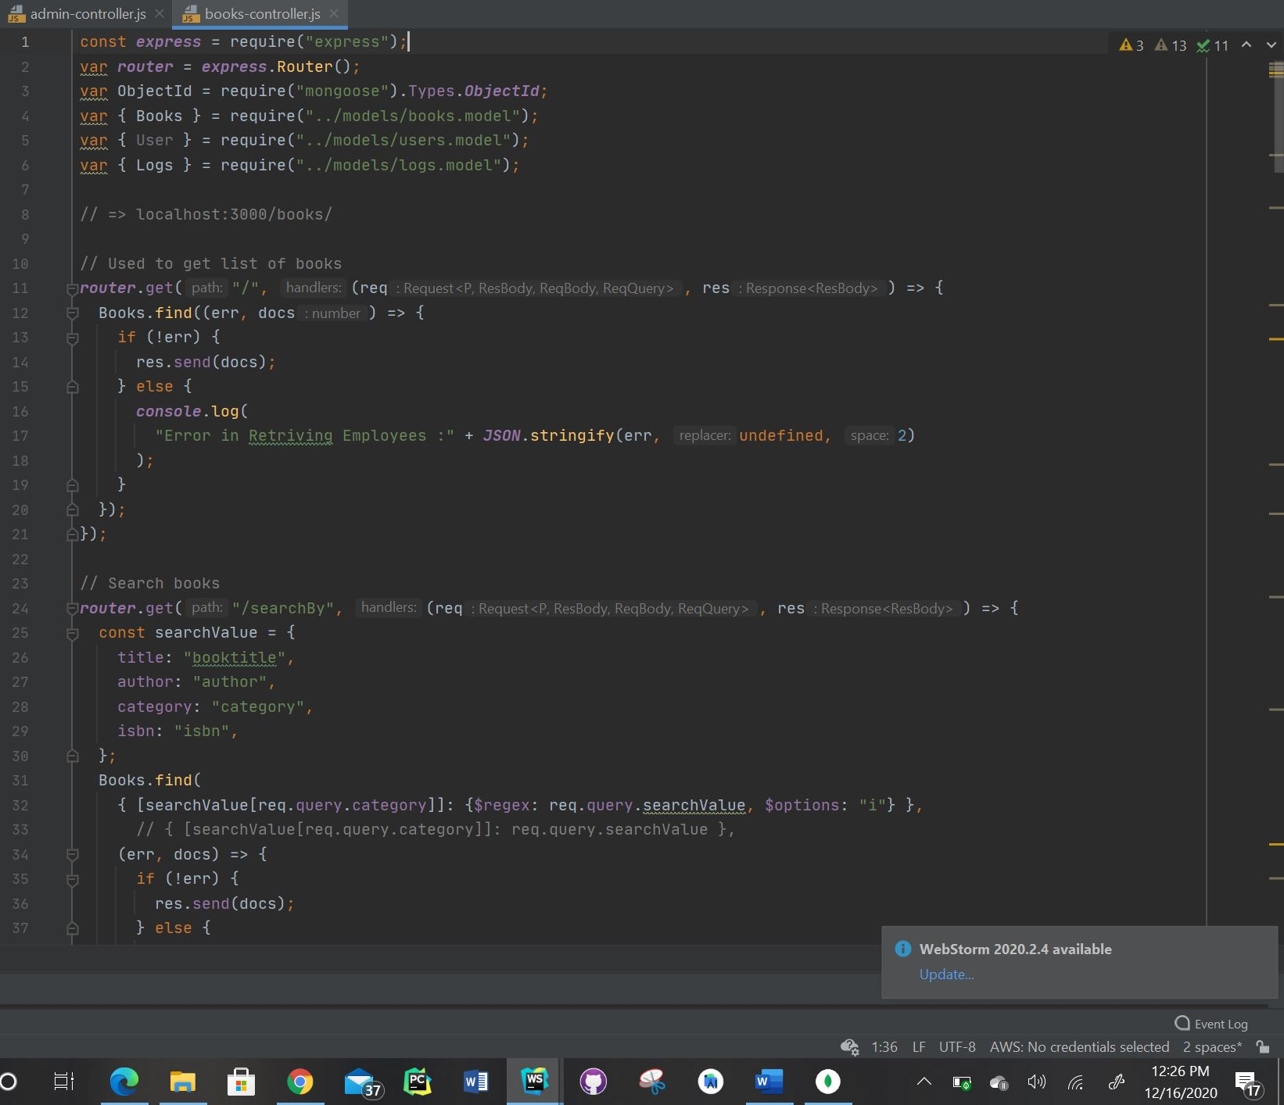

* Please find the screenshot for login-controller.js for backend:

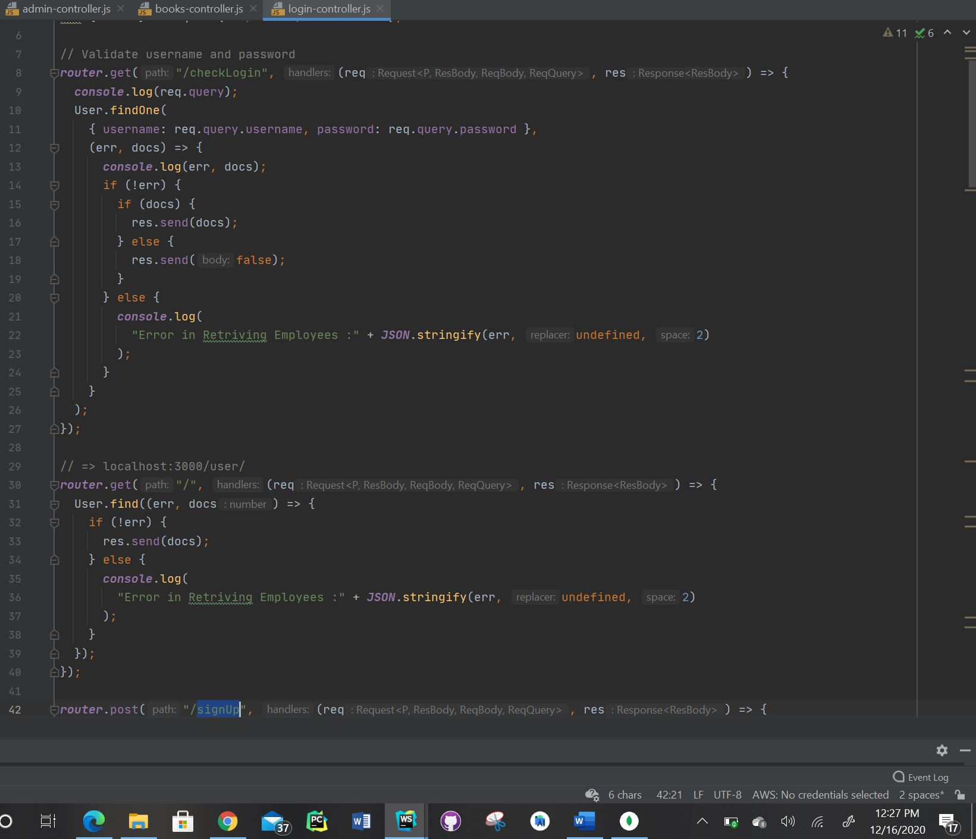

**Frontend:**

* Please find the screenshot for main.ts for frontend:

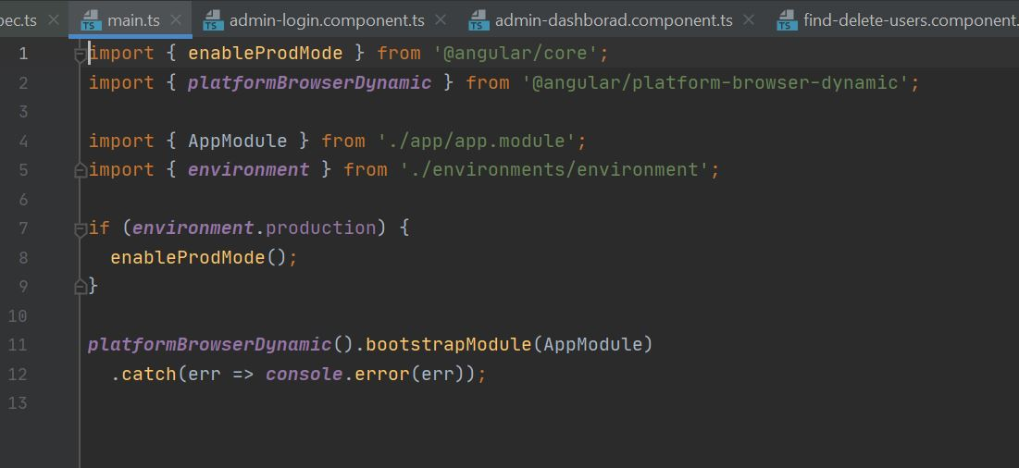

* Please find the screenshot for app.component.html for frontend:

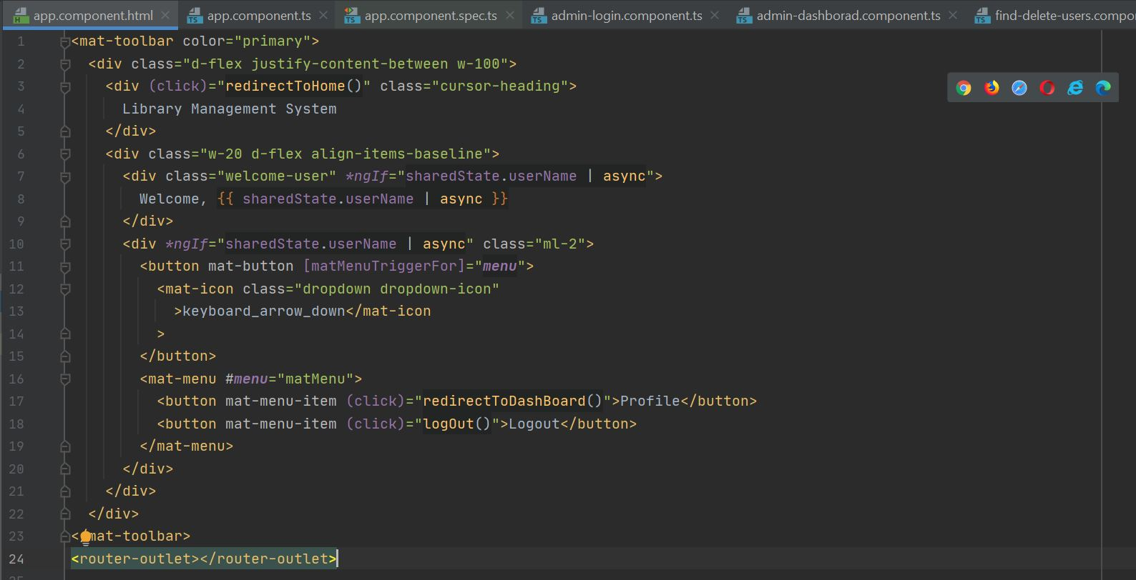

* Please find the screenshot for app.component.ts for frontend:

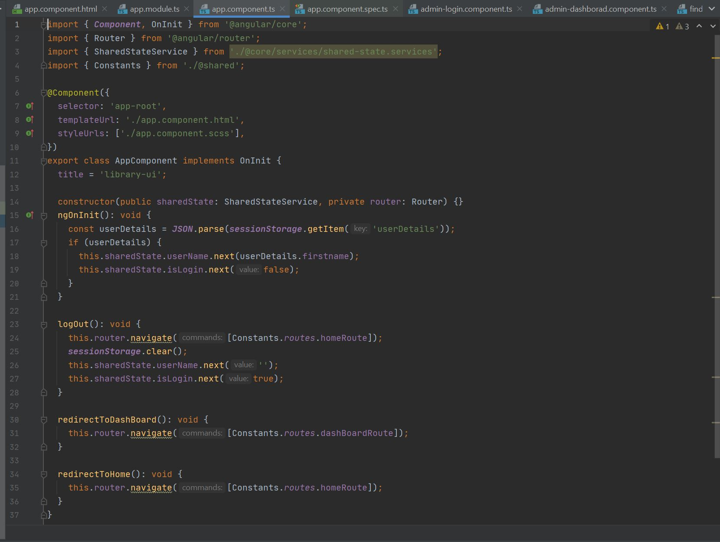

* Please find the screenshot for app.module.ts for frontend:

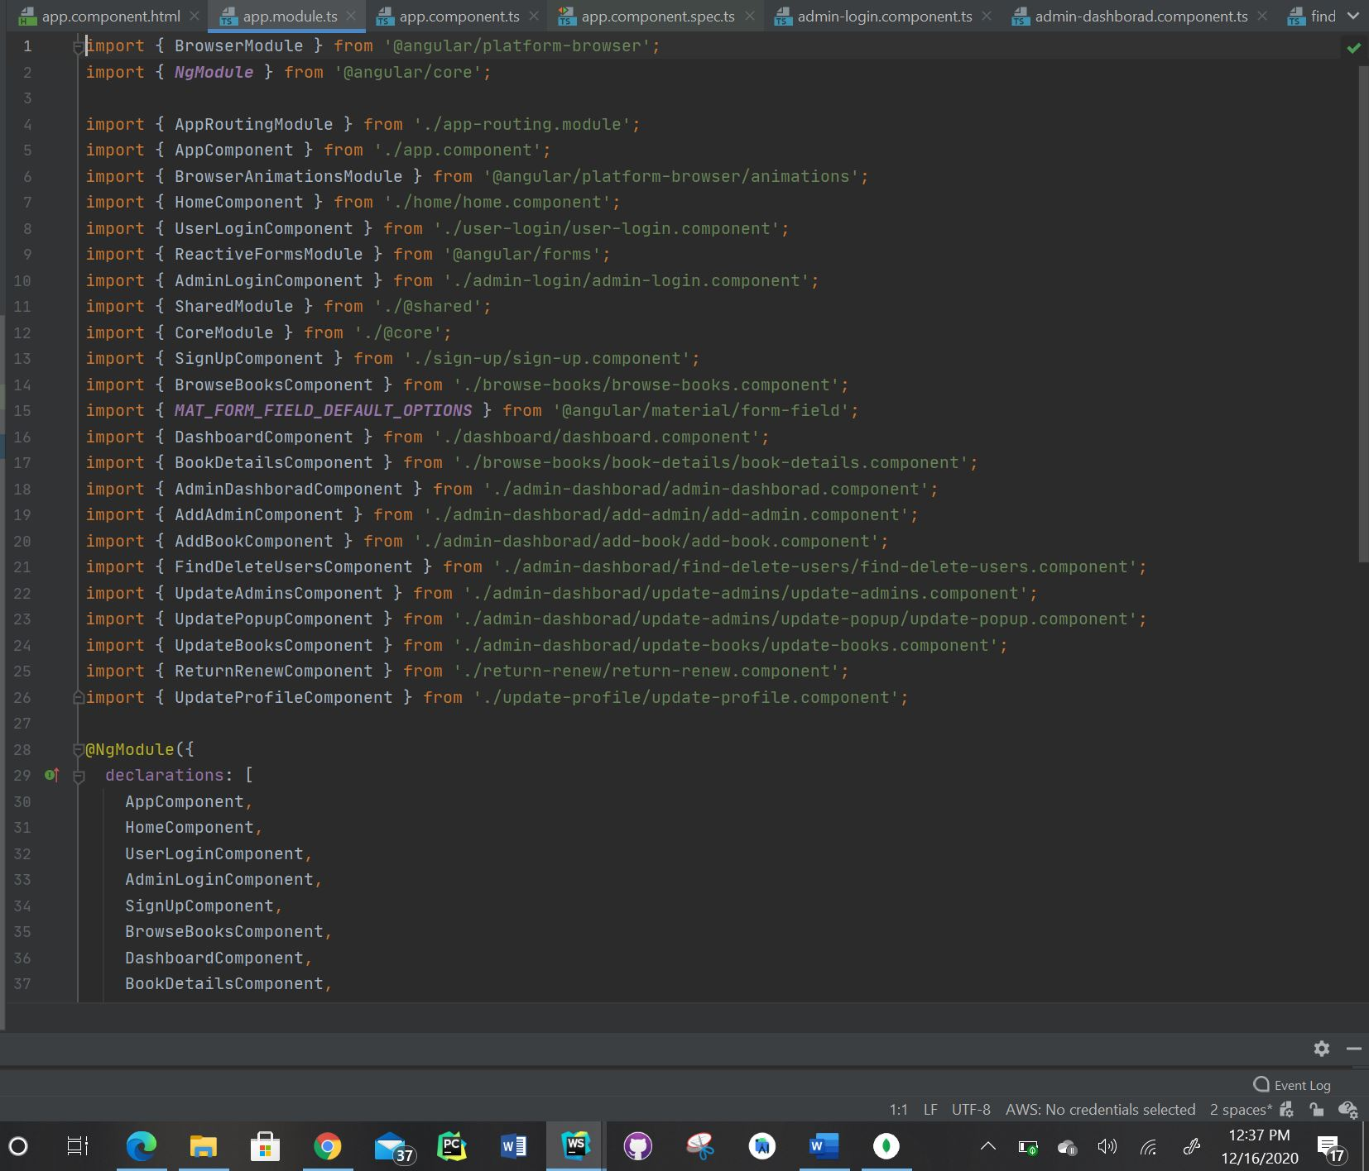

* Please find the screenshot for app-routing.module.ts for frontend:

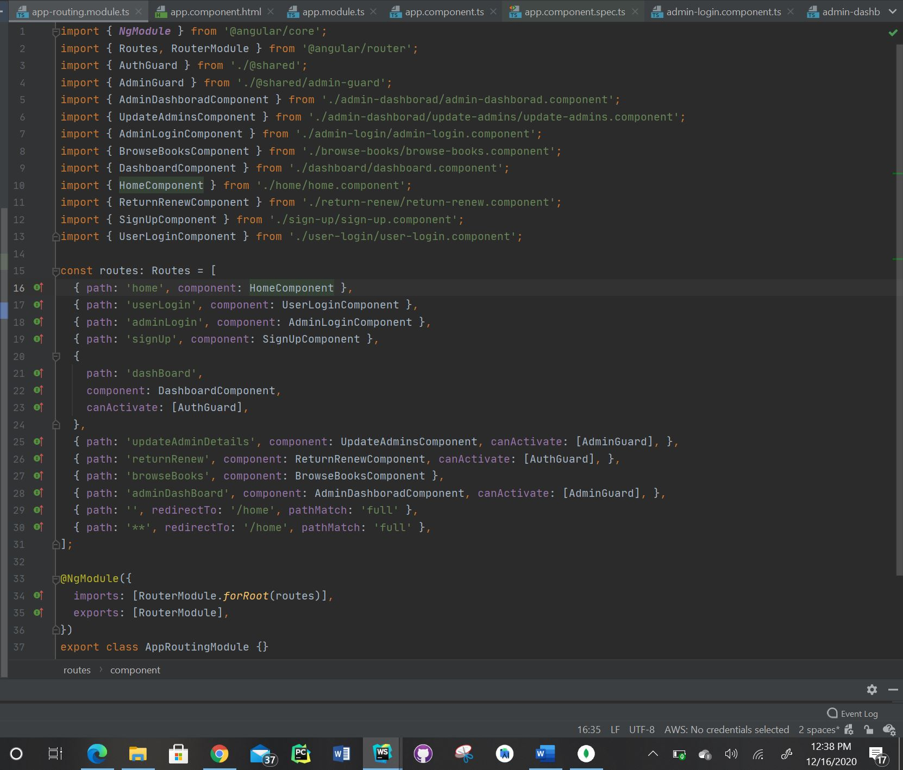

* Please find the screenshot for add-admin.component.html under admin dashboard for frontend:

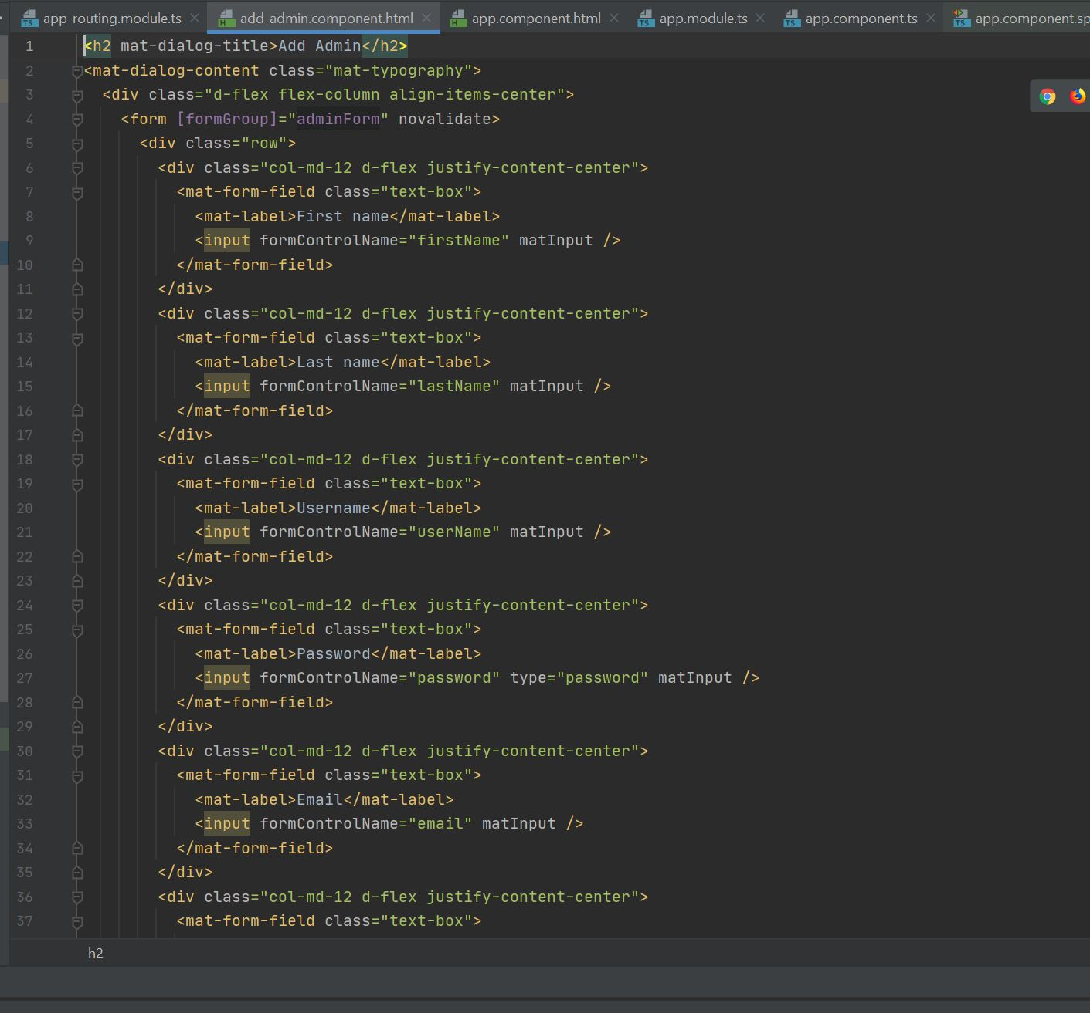

* Please find the screenshot for add-admin.component.ts under admin dashboard for frontend:

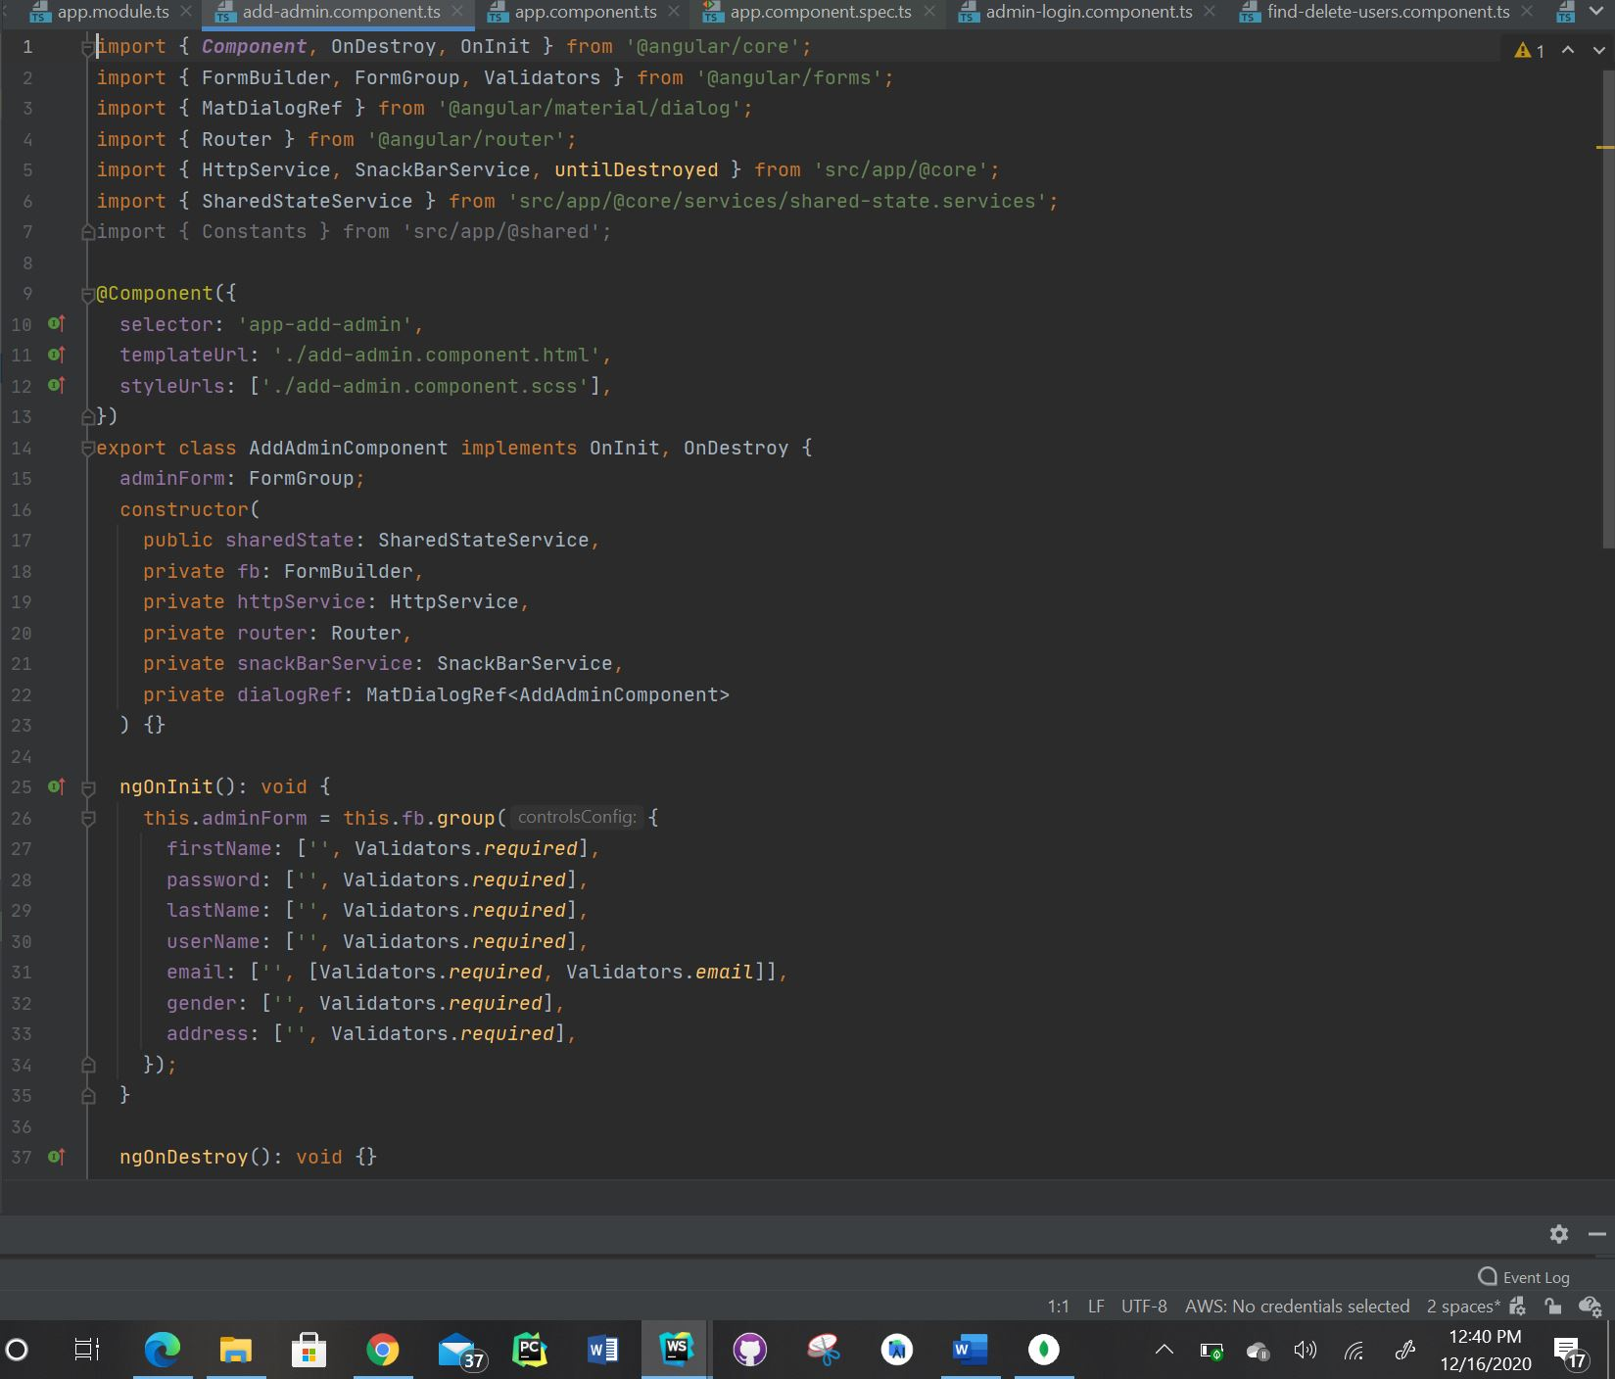

* Please find the screenshot for add-book.component.html under admin dashboard for frontend:

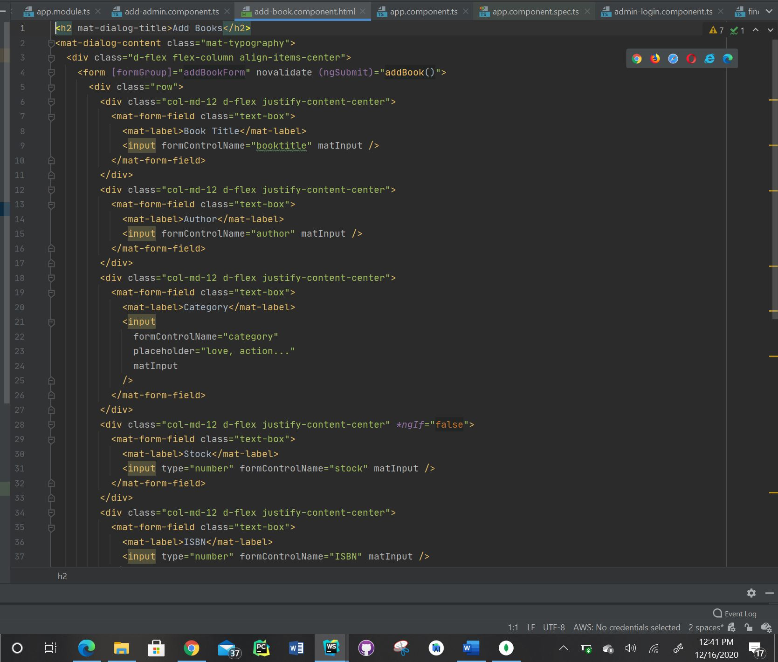

* Please find the screenshot for add-book.component.ts under admin dashboard for frontend:

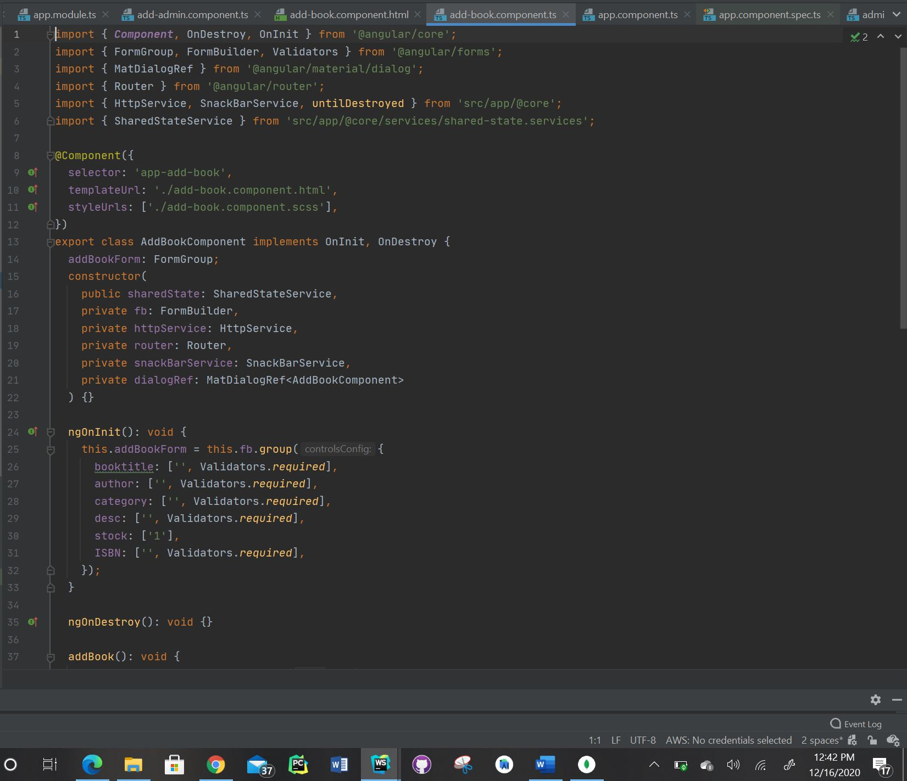

* Please find the screenshot for find-delete-users.component.html under admin dashboard for frontend:

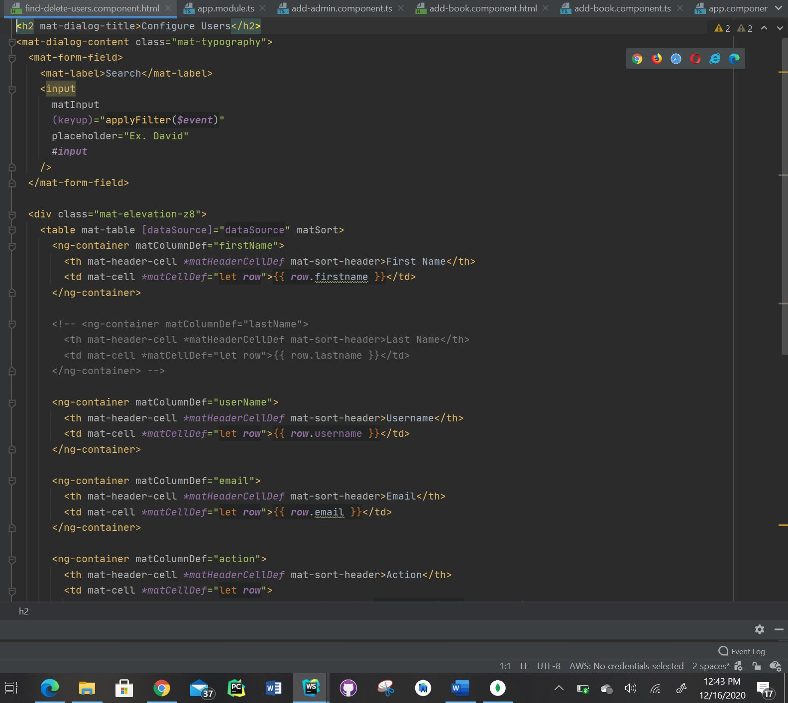

* Please find the screenshot for find-delete-users.component.ts under admin dashboard for frontend:

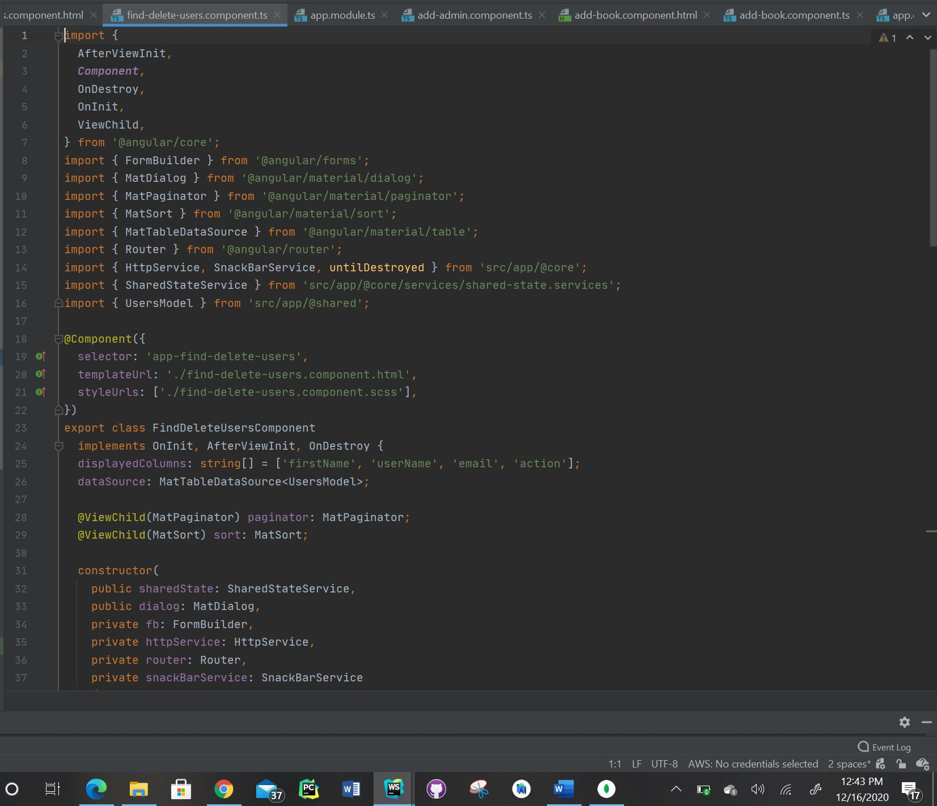

* Please find the screenshot for update-admins.component.html under admin dashboard for frontend:

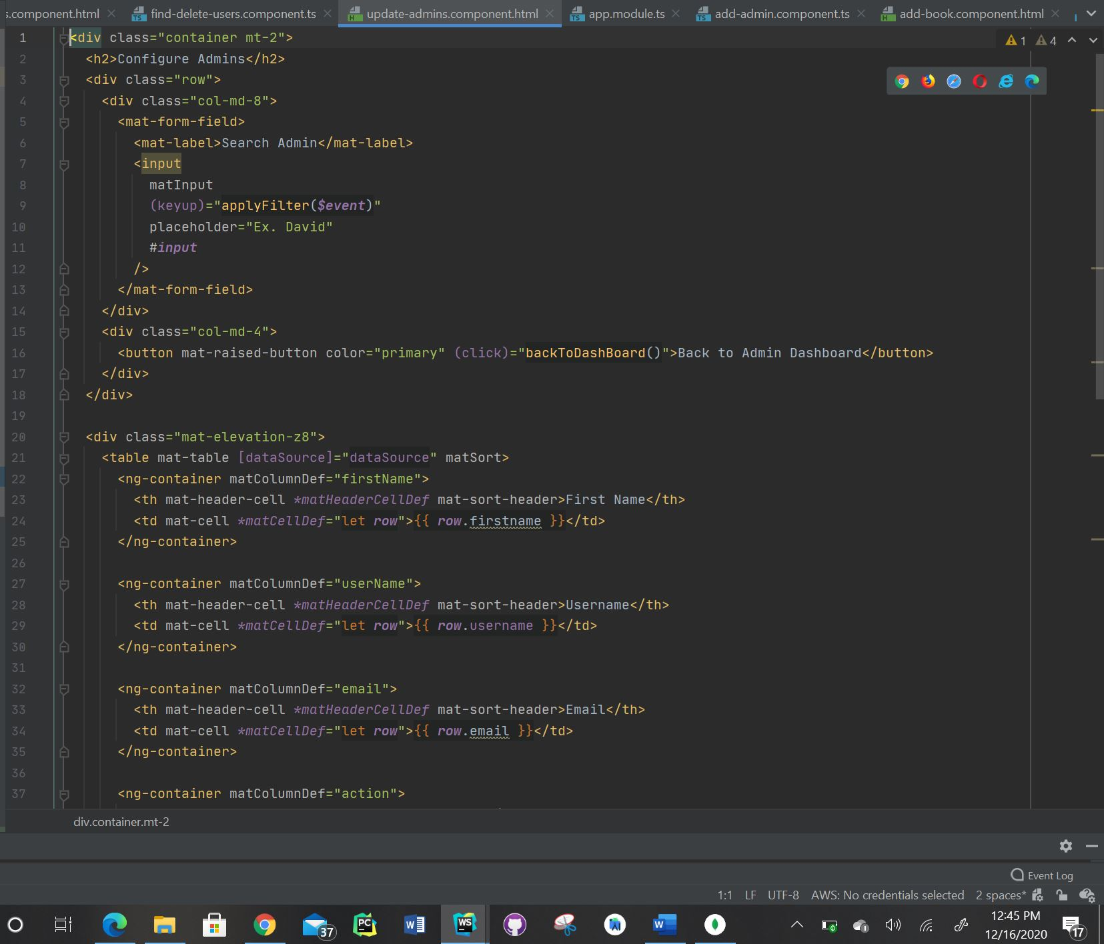

* Please find the screenshot for update-admins.component.ts under admin dashboard for frontend:

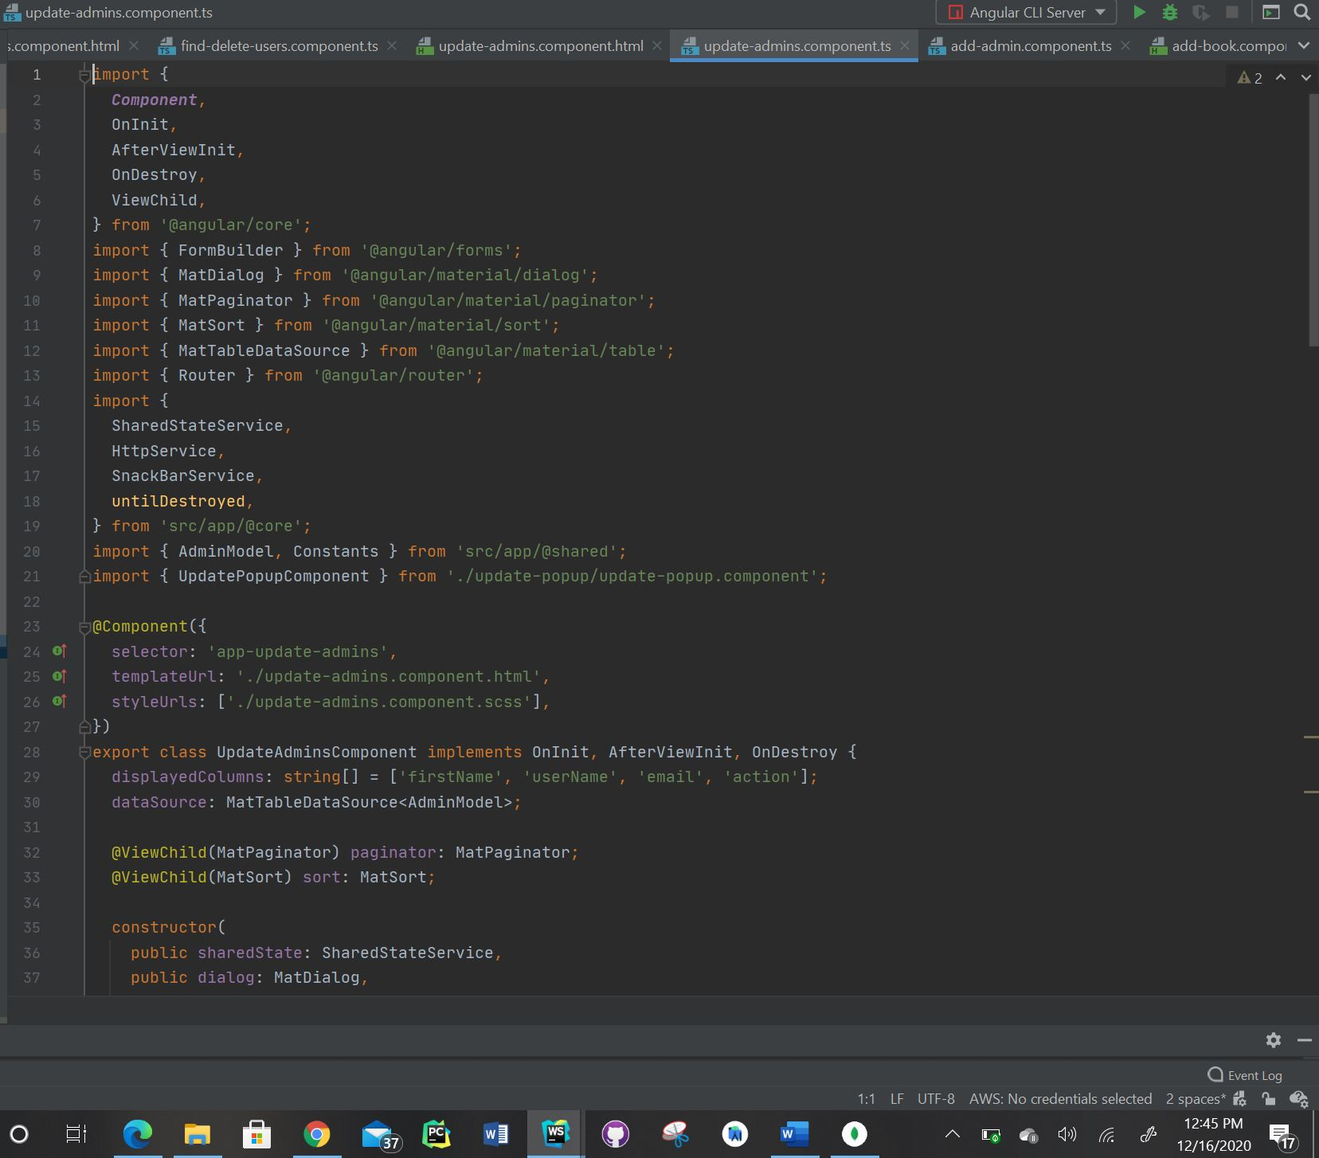

* Please find the screenshot for update-books.component.html under admin dashboard for frontend:

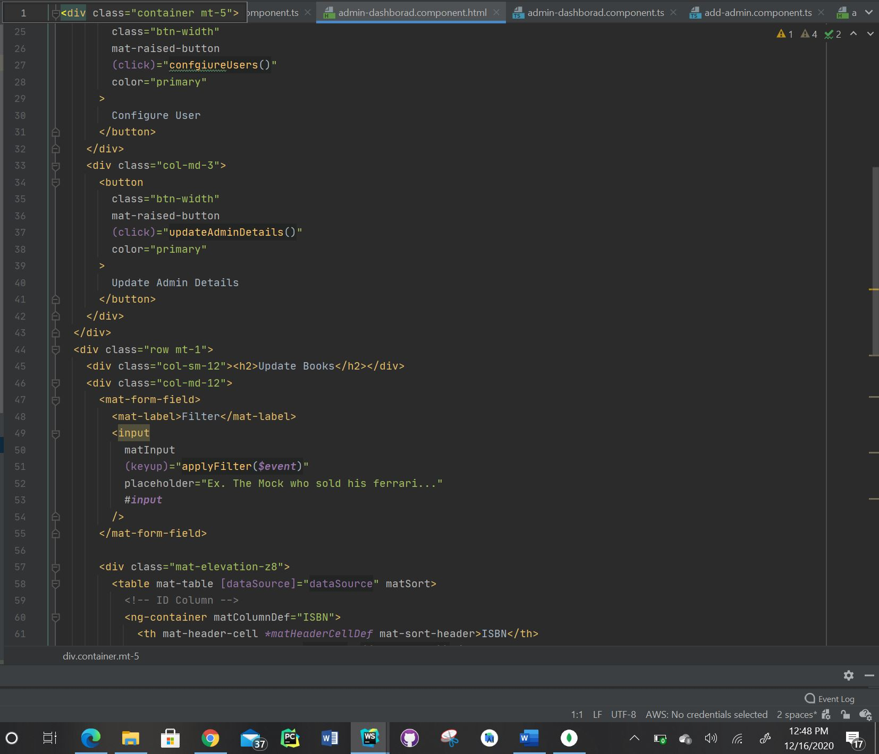

* Please find the screenshot for update-books.component.ts under admin dashboard for frontend:

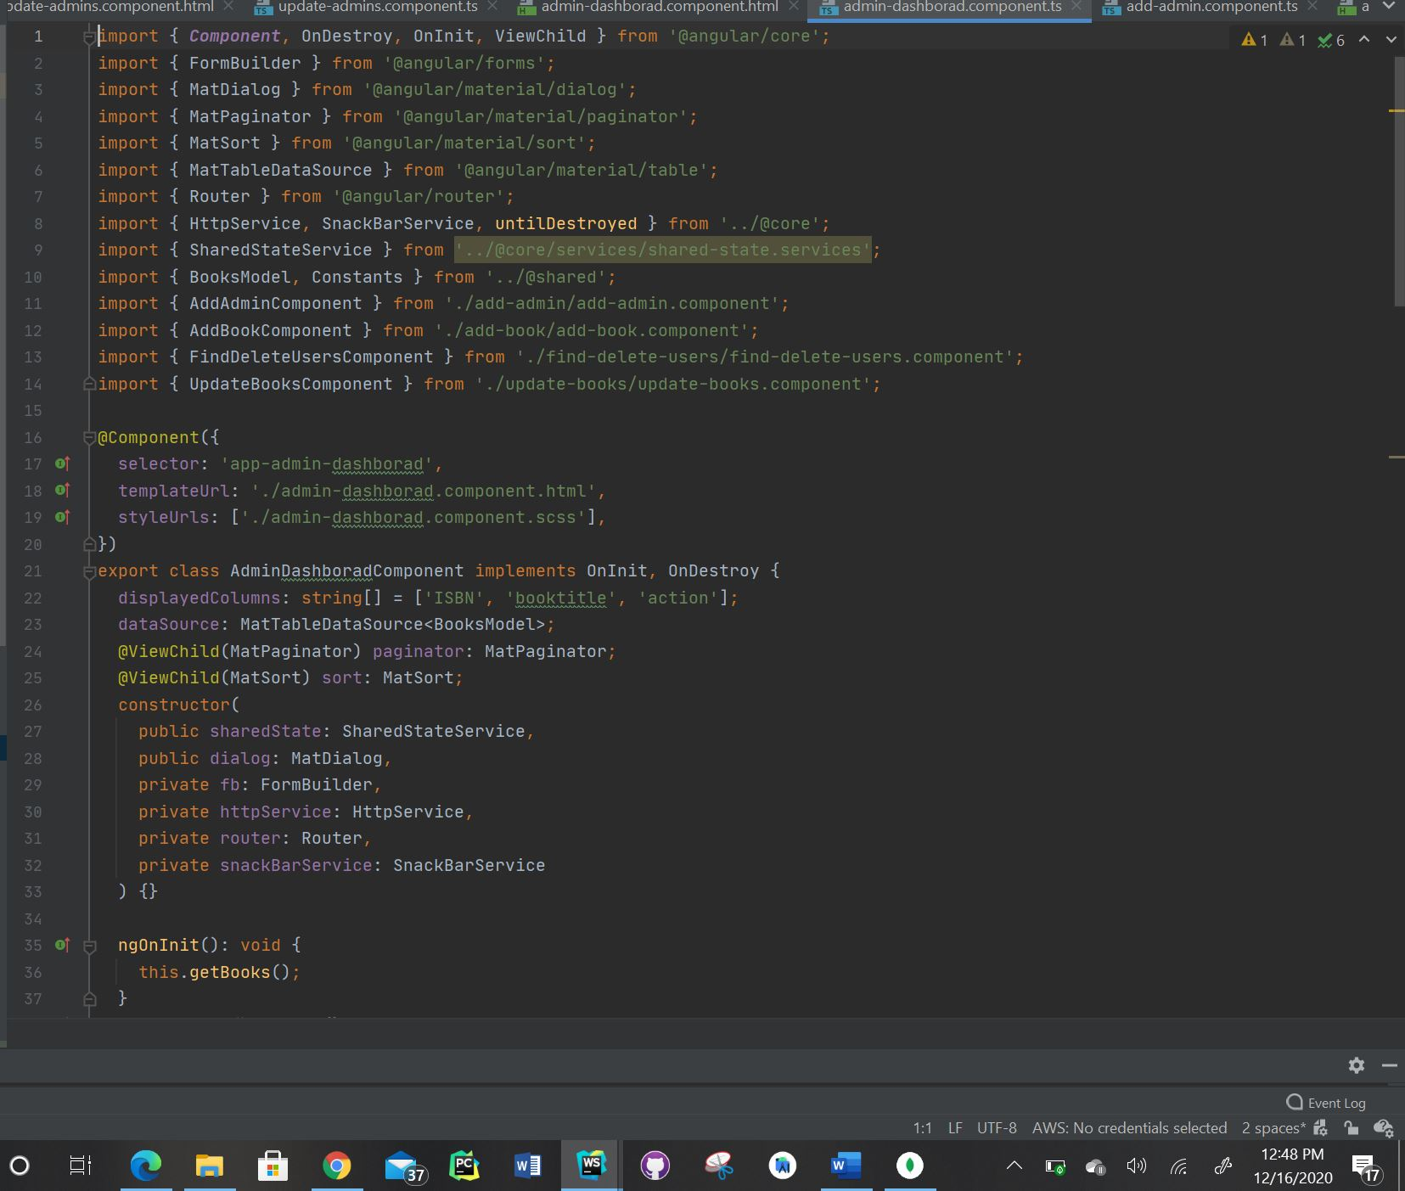

* Please find the screenshot for admin-login.component.ts for frontend:

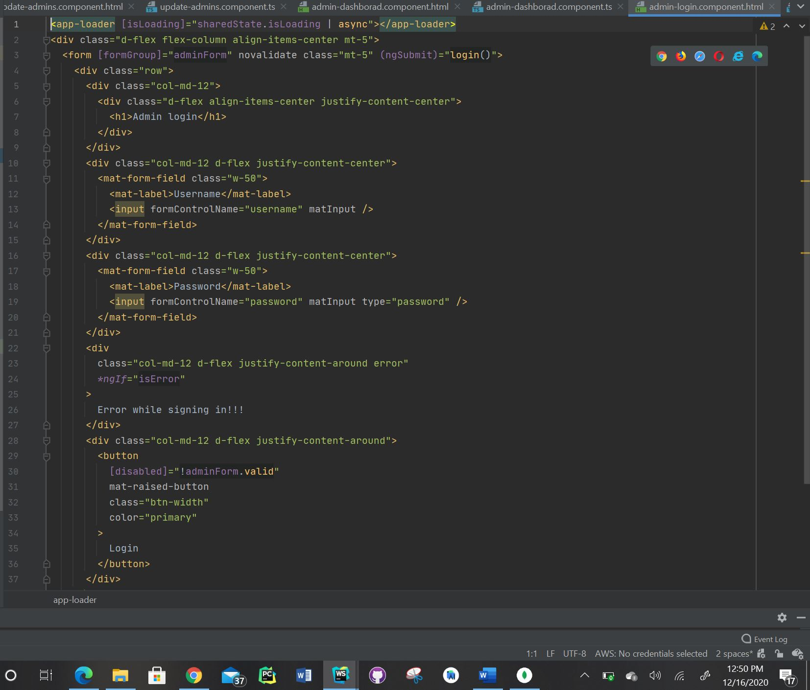

* Please find the screenshot for admin-login.component.ts for frontend:

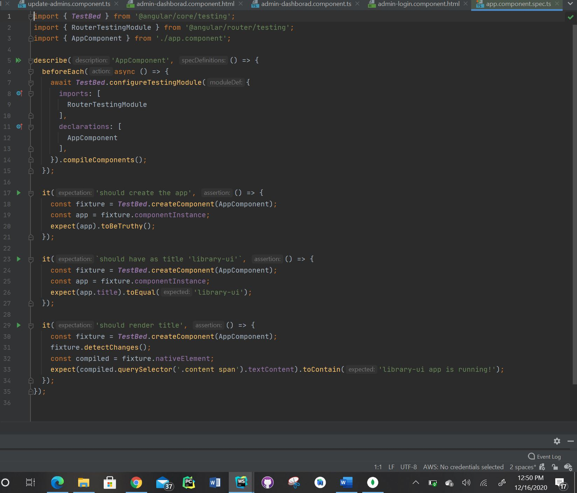

* Please find the screenshot for browse-books.component.html for frontend:

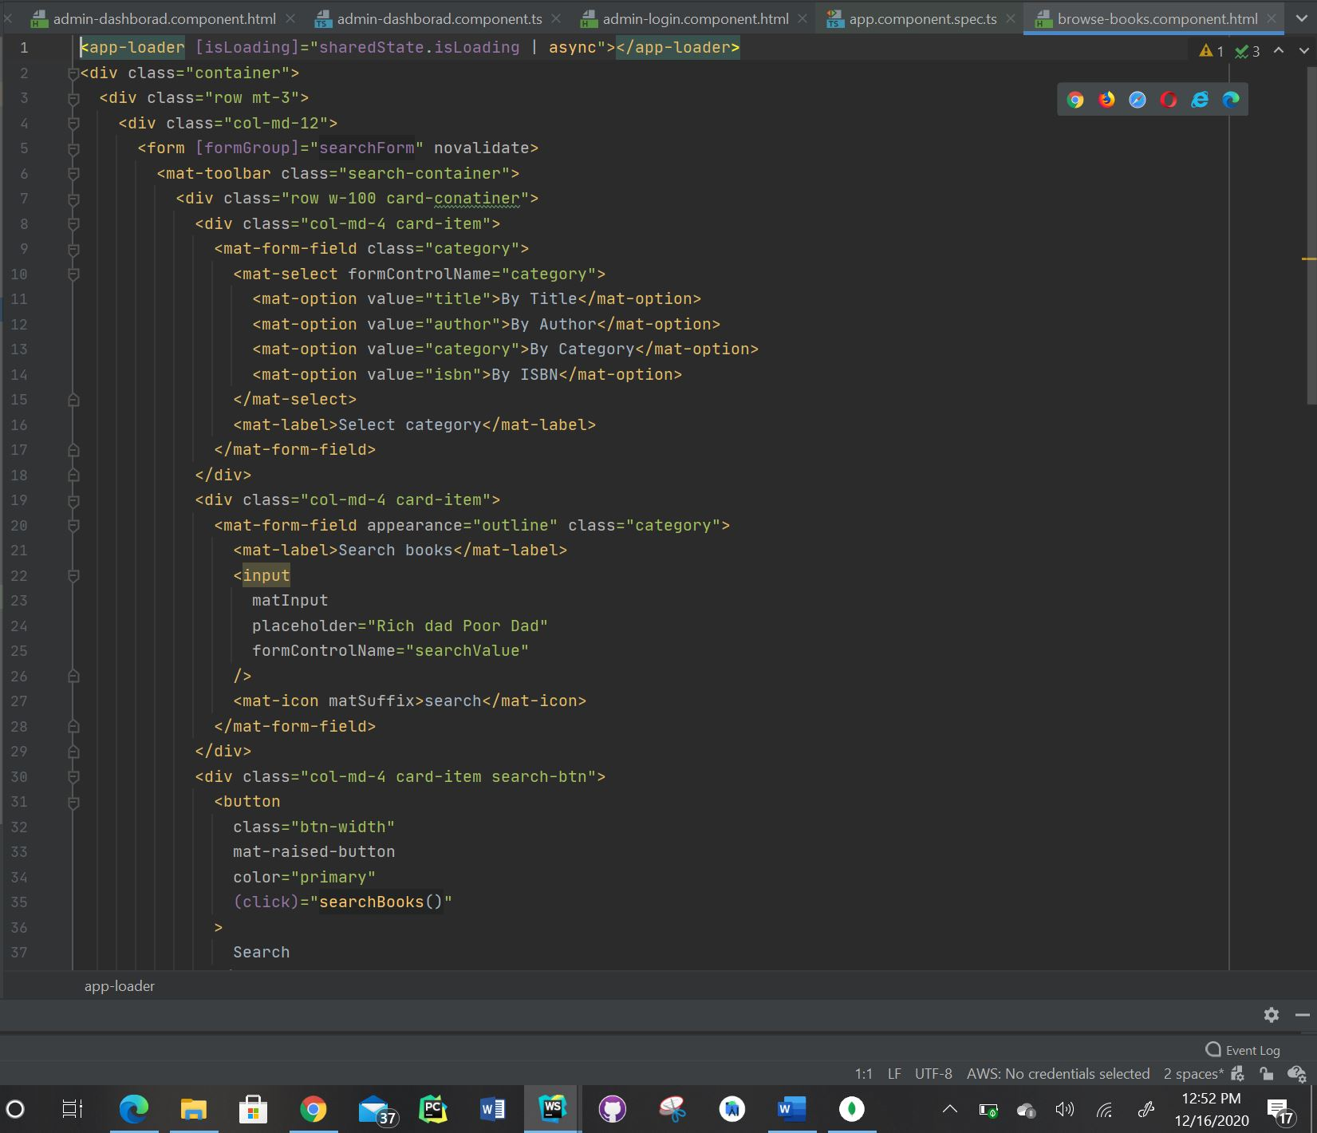

* Please find the screenshot for browse-books.component.ts for frontend:

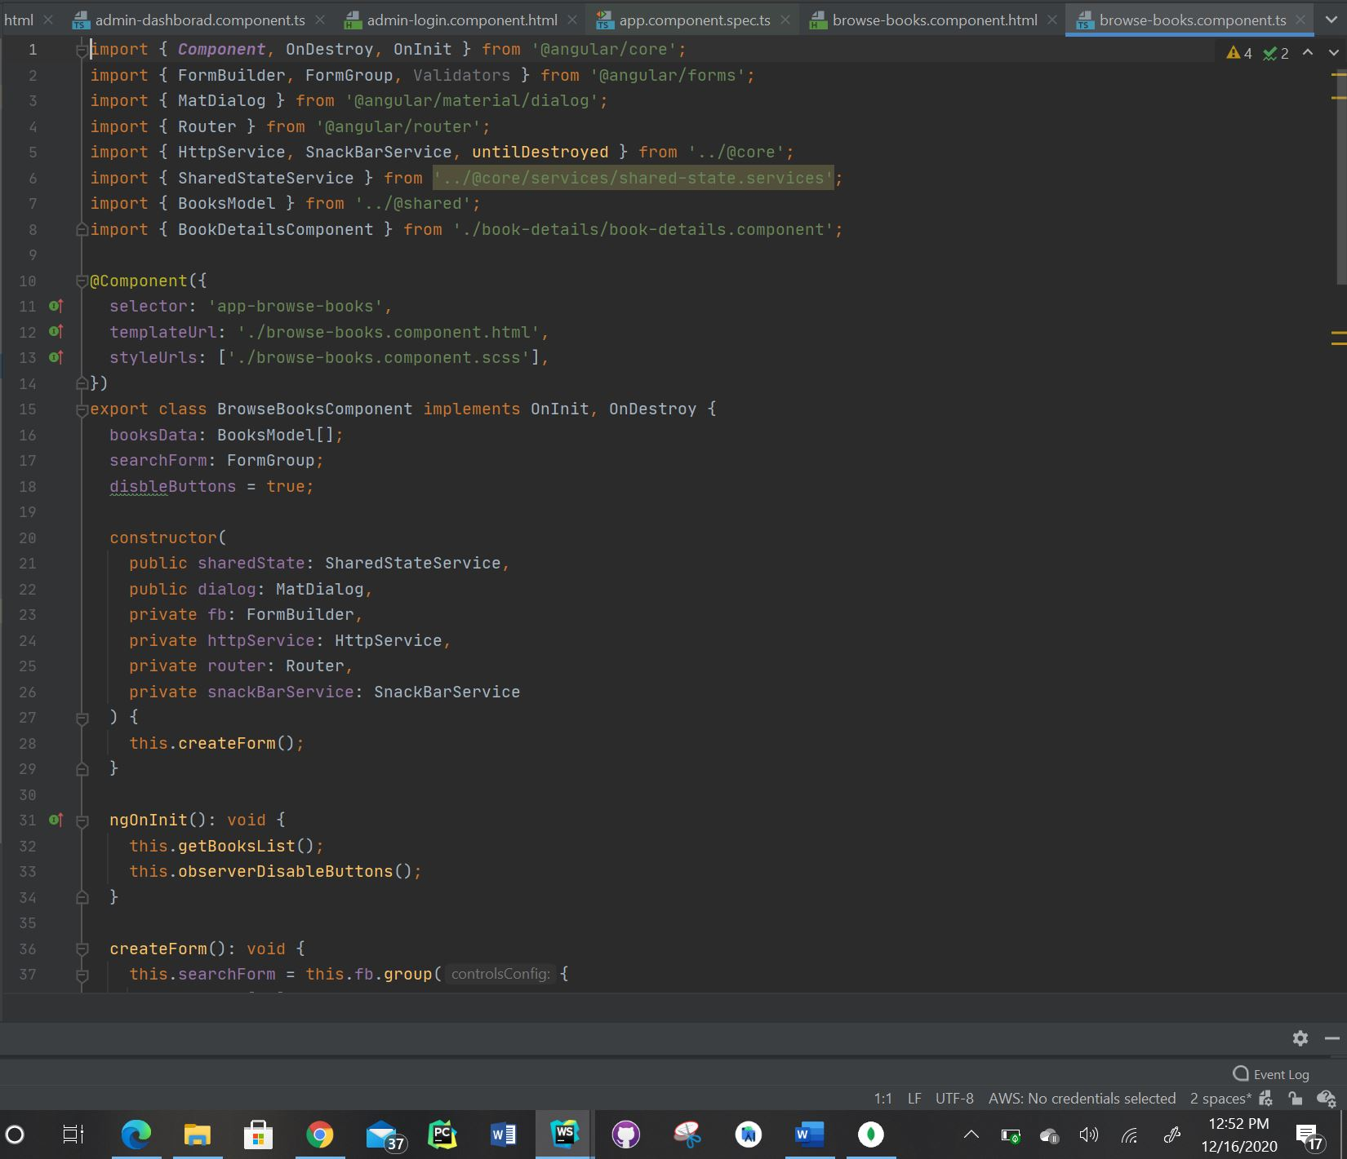

* Please find the screenshot for dashboard.component.html for frontend:

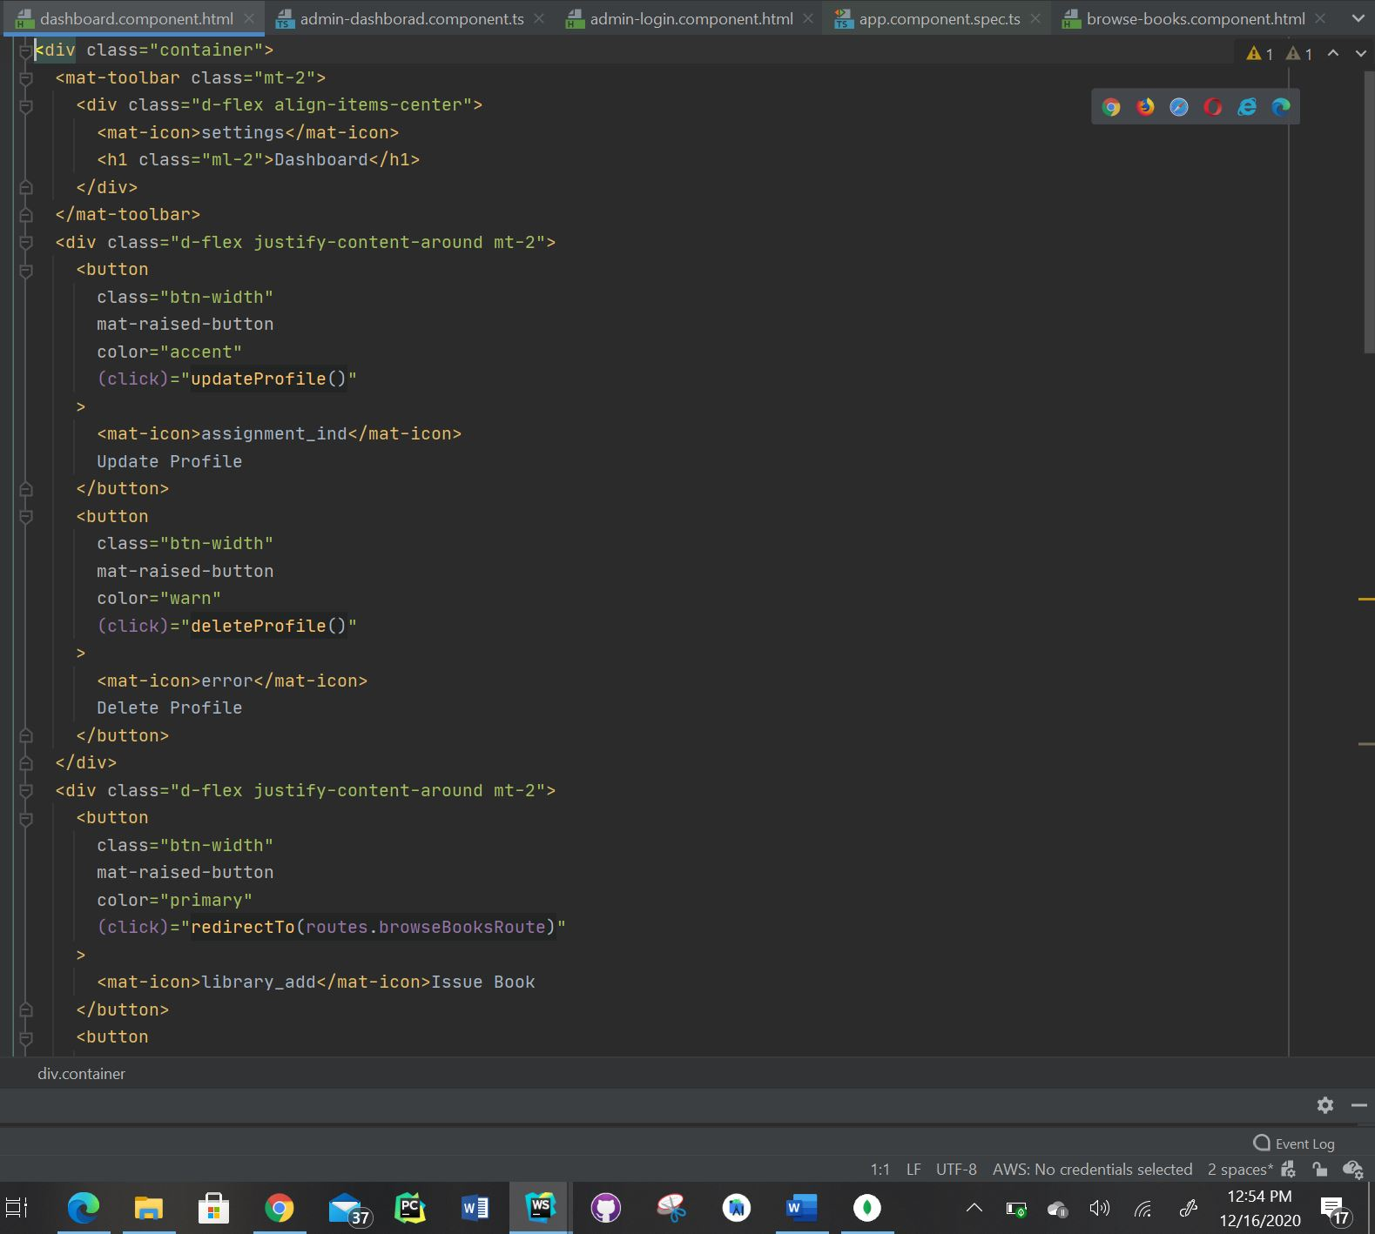

* Please find the screenshot for dashboard.component.ts for frontend:

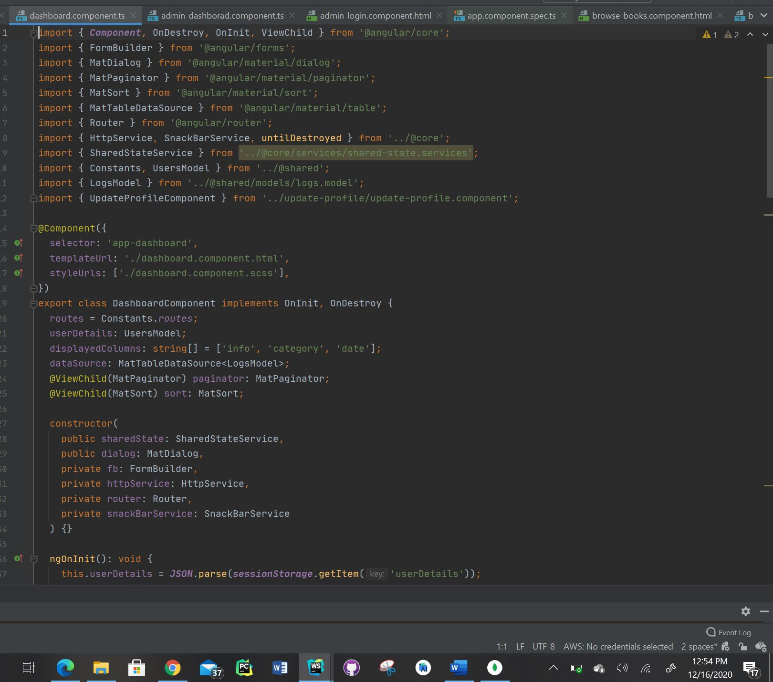

* Please find the screenshot for home.component.html for frontend:

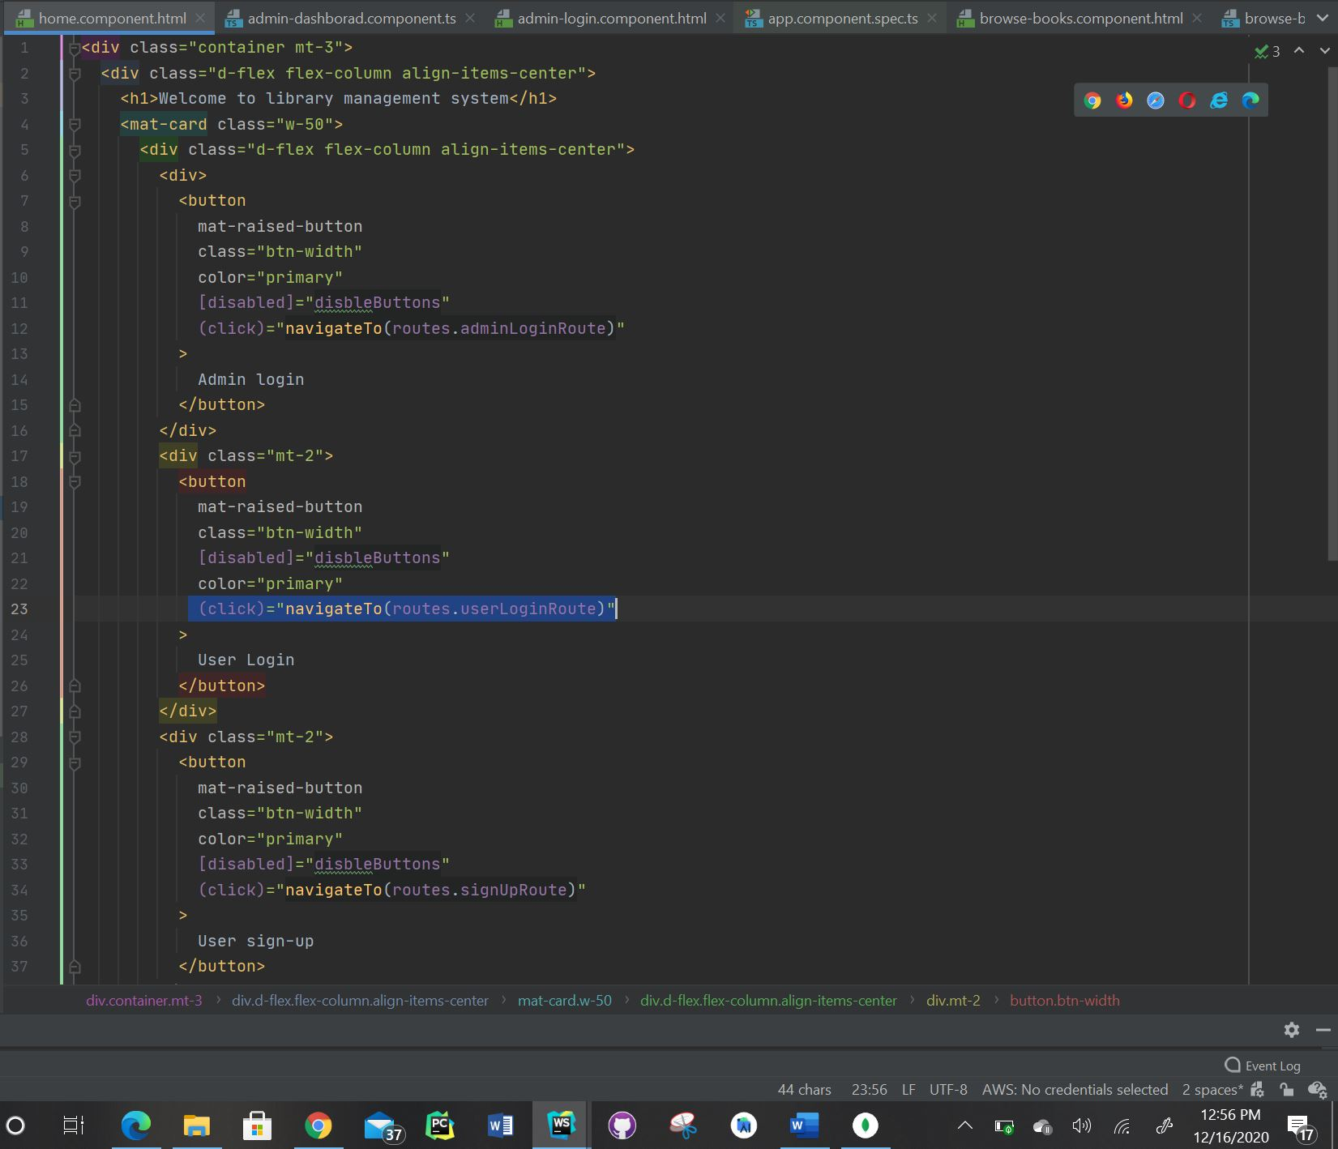

* Please find the screenshot for home.component.ts for frontend:

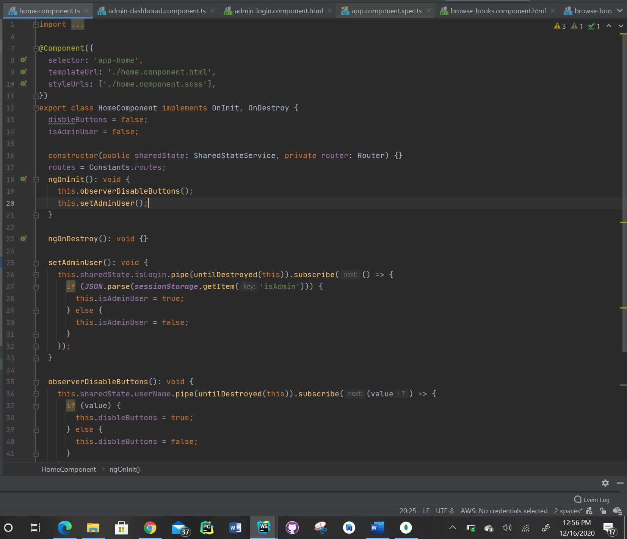

* Please find the screenshot for return-renew.component.html for frontend:

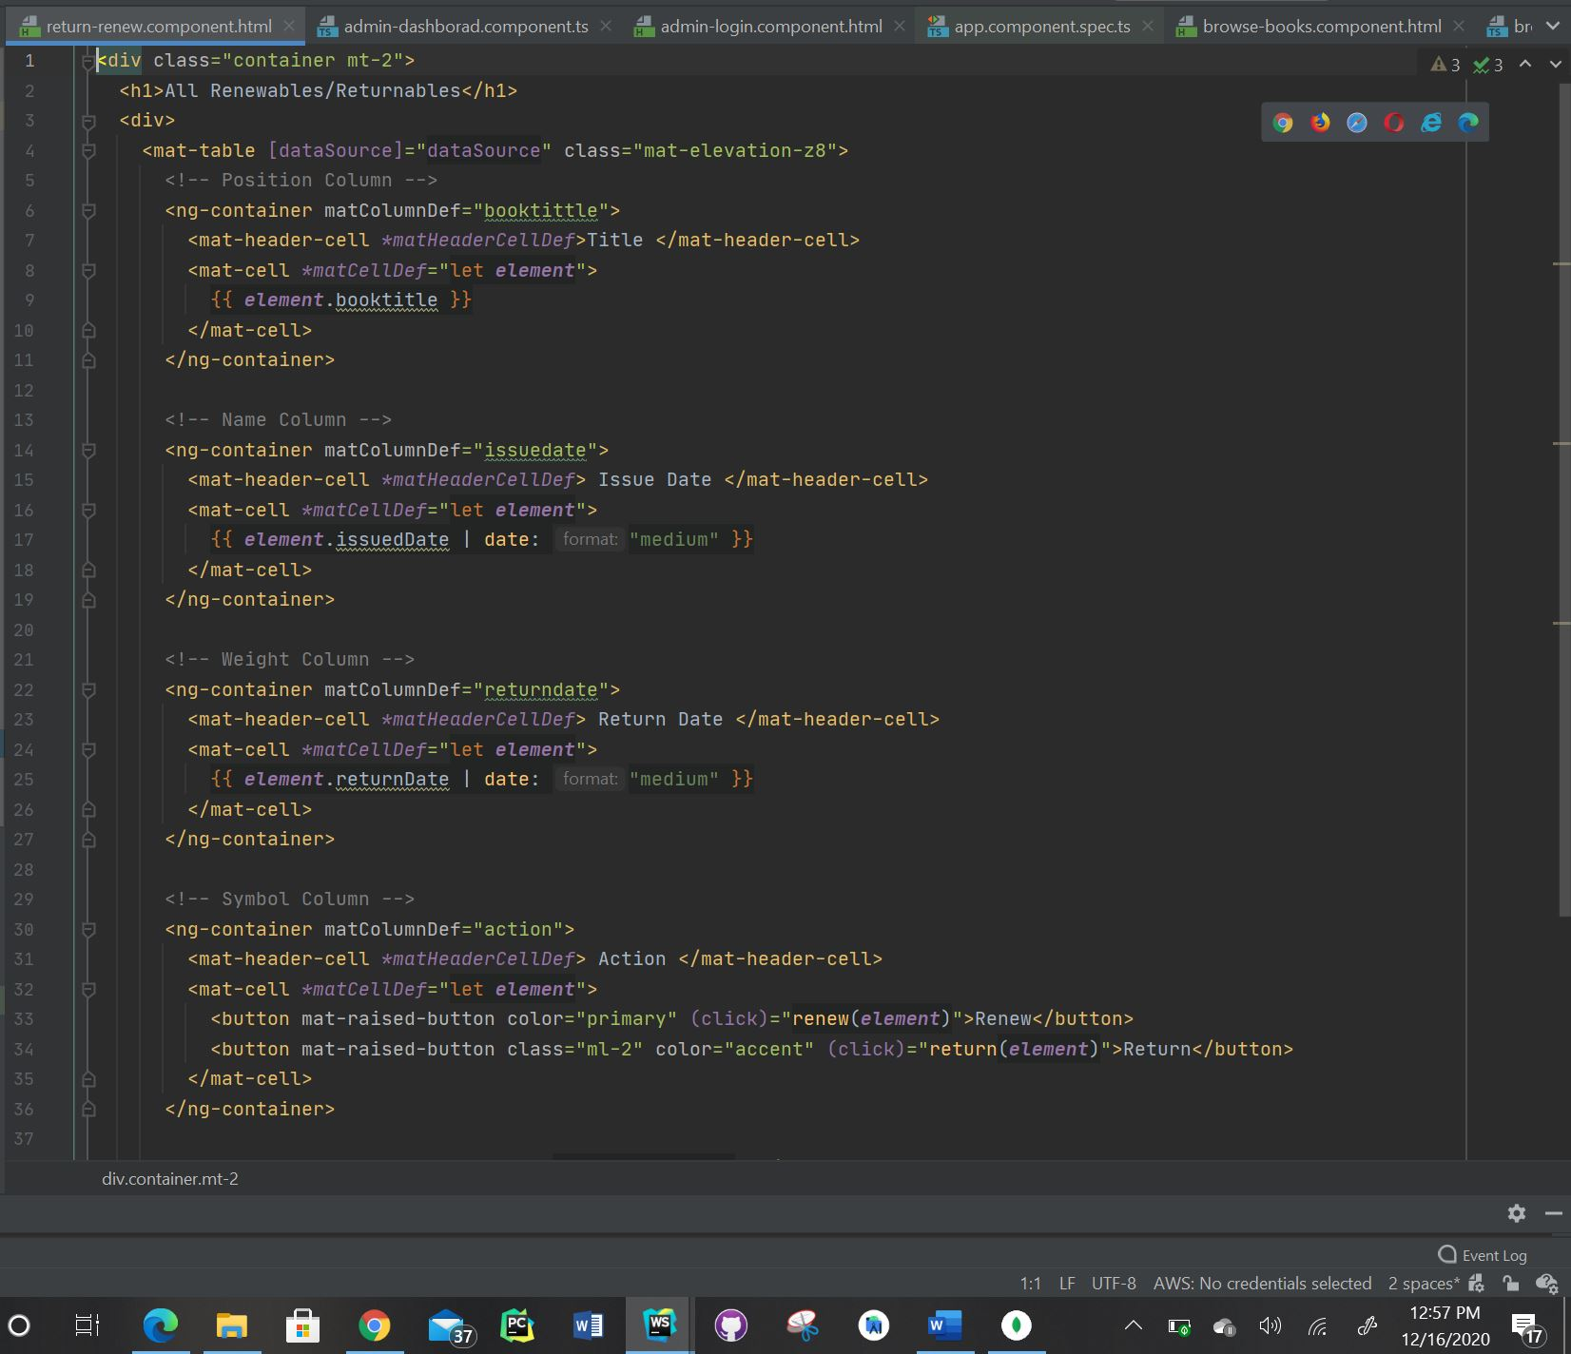

* Please find the screenshot for return-renew.component.ts for frontend:

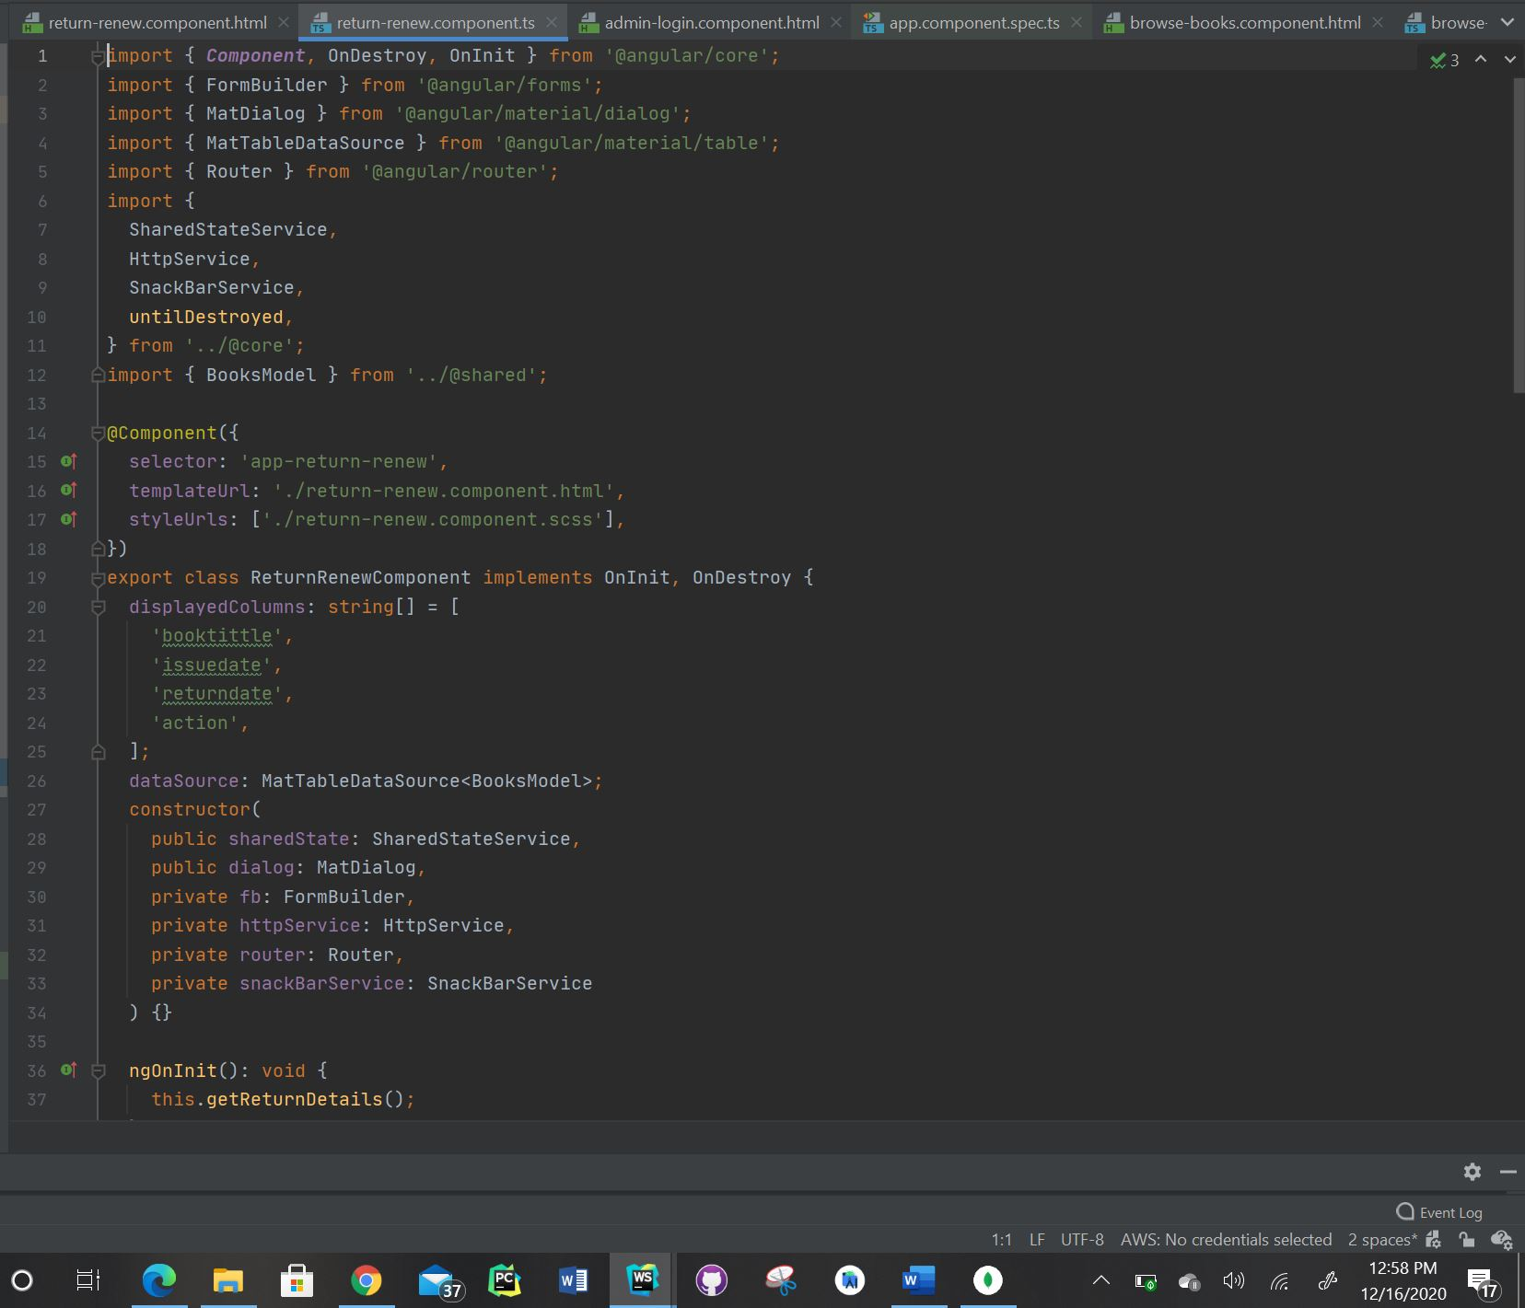

* Please find the screenshot for sign-up.component.html for frontend:

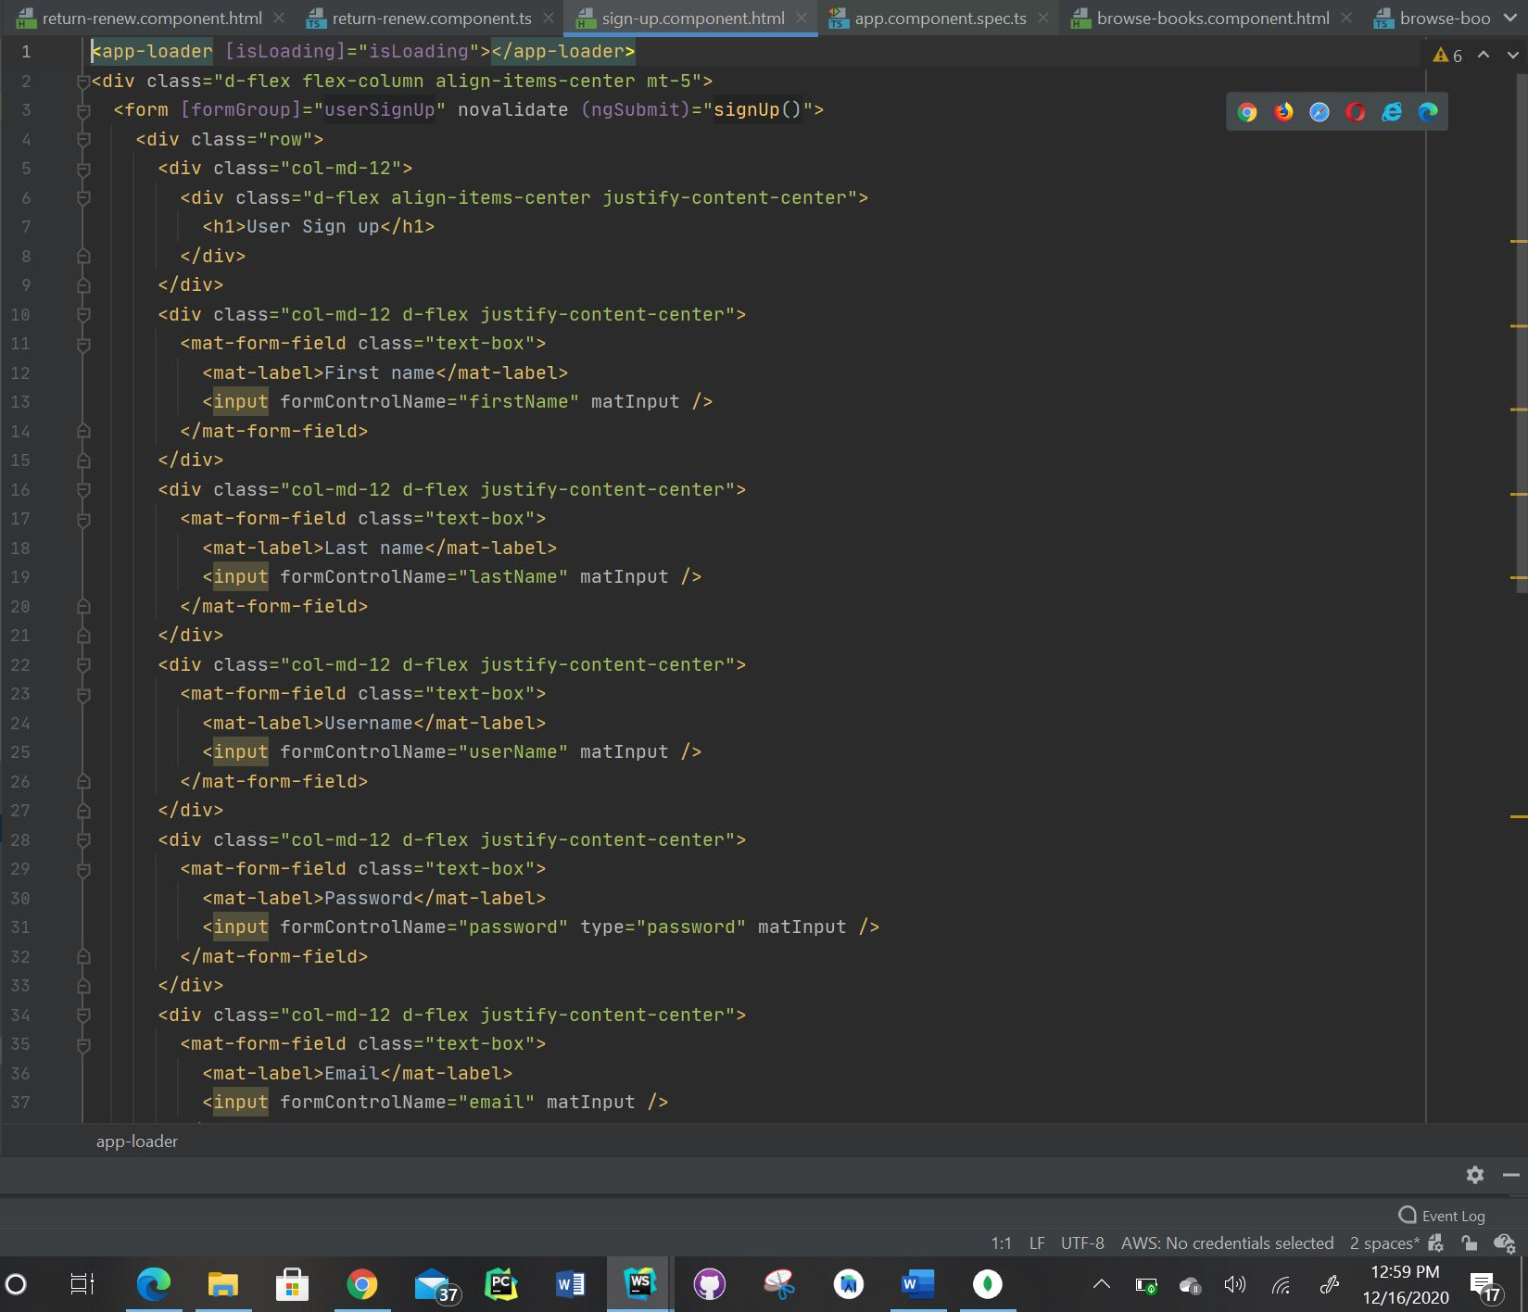

* Please find the screenshot for sign-up.component.ts for frontend:

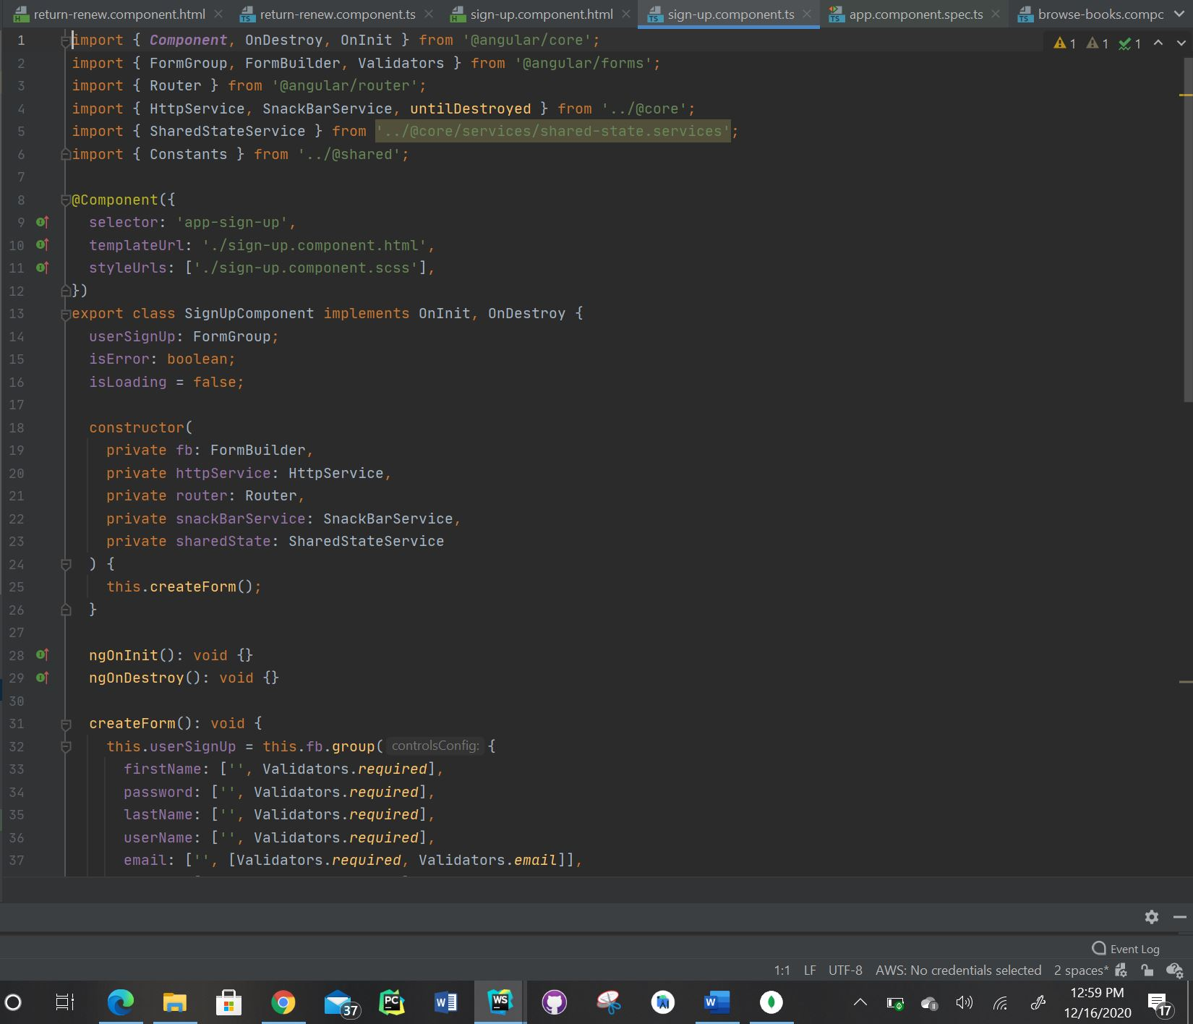

* Please find the screenshot for update-profile.component.html for frontend:

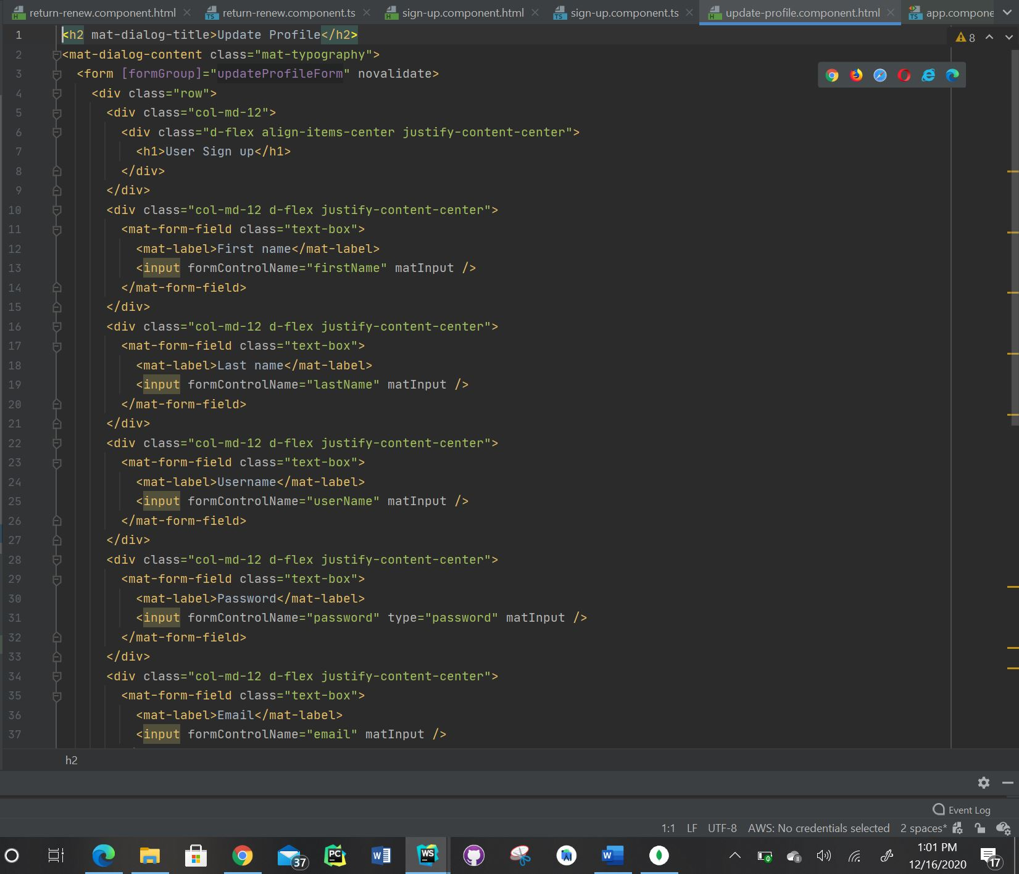

* Please find the screenshot for update-profile.component.ts for frontend:

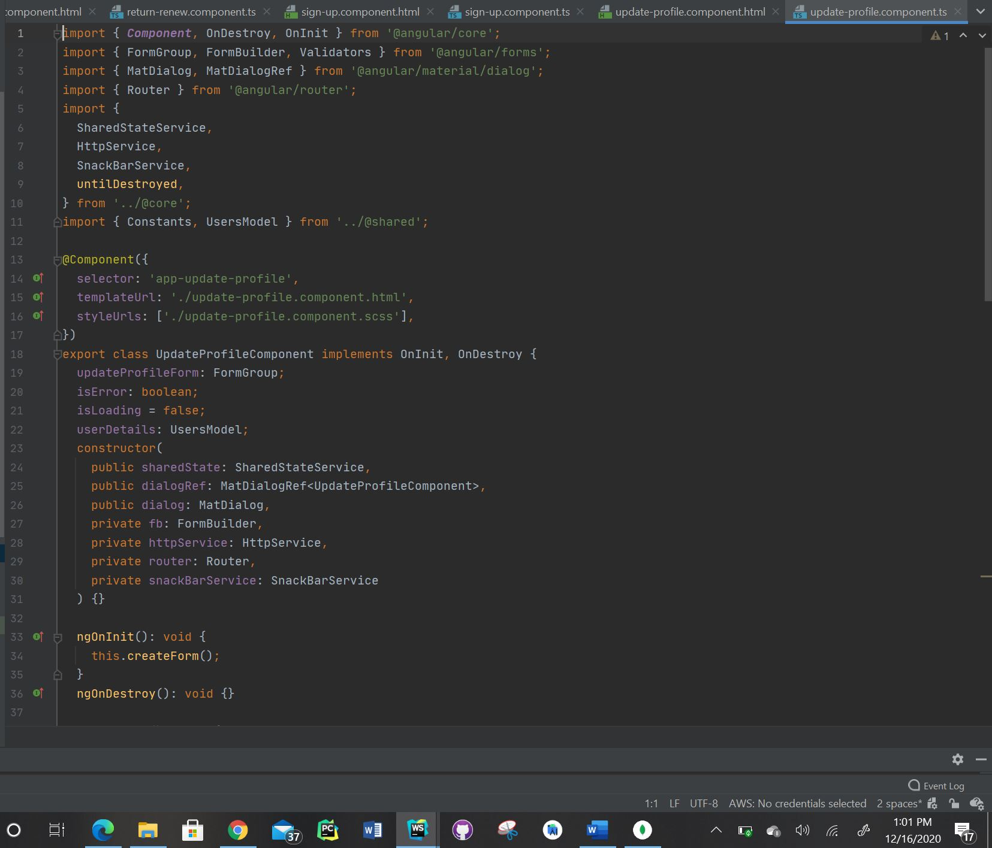

* Please find the screenshot for user-login.component.html for frontend:

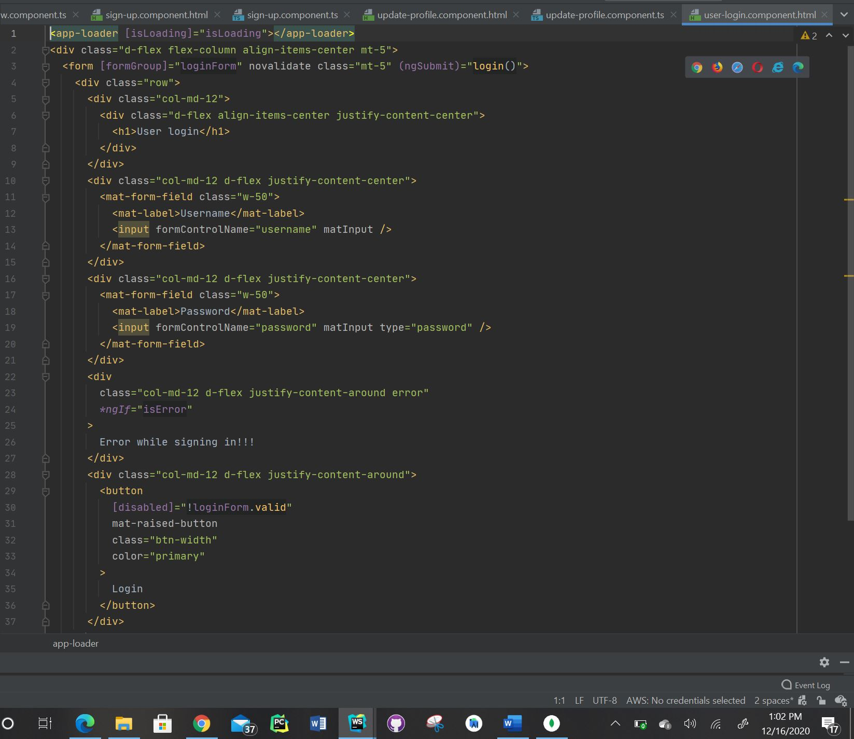

* Please find the screenshot for user-login.component.ts for frontend:

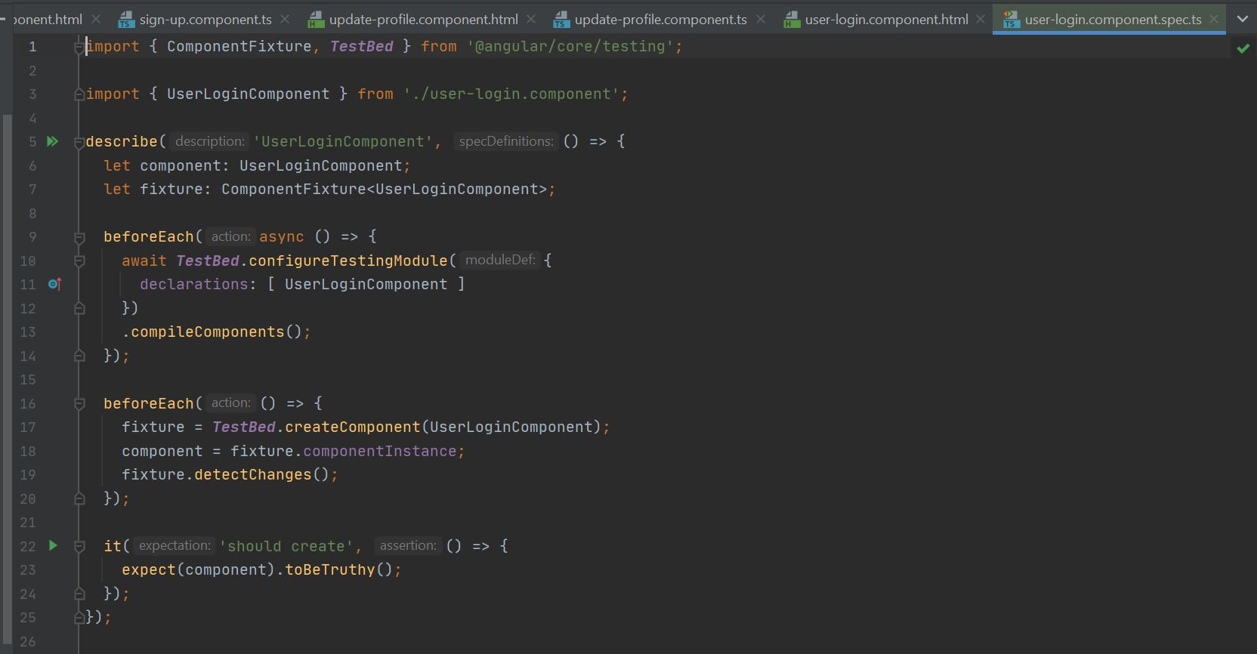

**Division of Work:**

* Admin Privileges and Documentation: Lalith Chandra Attaluri
* User Privileges: Udaya Byreddy
* Mongo DB Cluster, Login & Signup page: Madhu Varma Rudraraju

**References:**

* <https://docs.mongodb.com/guides/server/import/>
* <https://angular-templates.io/tutorials/about/learn-how-to-build-a-mean-stack-application>
* <https://mherman.org/blog/handling-user-authentication-with-the-mean-stack/>

**Github Link:**

https://github.com/RMVarma/Library_Management_System

**Video Link:**

https://youtu.be/cg_9NnhLq5w